Vaccine safety evidence
Assembled by Steve Kirsch (Twitter: @stkirsch) with help from Dr. Robert Malone

Executive Summary
It is now well established in the peer reviewed literature that the spike protein is toxic. The vaccines cause the spike protein to be manufactured for up to 48 hours in all parts of the body including the brain thanks to the efficient delivery mechanism of the lipid nanoparticles and PEG. The spike proteins produced in these cells do not remain anchored as designed; they also break off the cell and become “free spike” which is even more dangerous since it can circulate in the blood. The net result is inflammation and micro-clotting inside all organs (including the brain) throughout the body as well as temporary opening of the blood brain barrier (which explains the severe migraine headaches). This explains the wide range of neurological systems after injection.

The mechanism of action is confirmed in the data. The VAERS database shows that over 6,000 people have possible vaccine-related deaths as well as over 300,000 SARs that are consistent with the mechanism of action. If we remove 500 “background deaths” in the VAERS system each year, we are left with over 5,500 “excess deaths” that are coincident with the vaccine rollout. The safety signals have been flashing “red” since January in VAERS, but nobody was paying attention (except for a few users on Twitter who were being ignored). This is a HUGE number of excess deaths and SARs. So the question for the CDC is “OK, if the vaccine did not kill these people, then what did?” This is not caused by excess reporting since doctors are less likely to make VAERS reports for the “safe” vaccine because nobody wants to create vaccine hesitancy. Doctors (such as Dr. Hoffe) have been fired for filing adverse event reports and speaking out. Anyone who speculates this is simply excess reporting of “normal deaths” has the burden of proof since excess deaths that are

The Yellow Card system in the UK showed a similar safety signal. Independent analysis of that data by an expert in medical evidence concluded that the vaccines are unsafe for use in humans. It wasn’t a close call.

Even the WHO called for the vaccines not to be used in children, but political pressure forced them to recant just 48 hours later.

The cost-benefit analysis for anyone is a wash according to the scientific literature. This peer-reviewed paper looked at the real cost-benefit analysis and concluded that “This lack of clear benefit should cause governments to rethink their vaccination policy.”

Evaluation of individual VAERS records show the cause of death is consistent with the mechanism of action of the vaccine and have no other explanation, e.g., a healthy 20 year old who dies in his sleep less than 24 hours after vaccination. Half of the deaths reported are within 72 hours of vaccination. Through multiple methods, we show that the 5,500 deaths are under-reported by at least a factor of 5X, giving nearly 30,000 deaths.

Historically, the stopping condition for a vaccine is 25-50 deaths. But there is no stopping condition for this vaccine in the US or UK. The CDC claims nobody has died from the vaccine, but has produced no analysis showing this to be the case. They don’t even have the staff to investigate 6,000 death reports. They never even tried to hire the needed staff.

The required toxicology studies were never done. We have no idea on the reproductive tox. A LTE submitted to the NEJM pointed out that based on the data to date there is >82% spontaneous abortion rate at <20 weeks. We don’t know what the true number is because the data isn’t available to anyone. Thus, we are telling pregnant women to get vaccinated even before we have any of the safety data. This is appalling. It is backwards. We are injecting first, doing safety studies later. What is this doing to the reproductive system of our kids? We don’t know.

The cost-benefit analysis for children is non-existent; it is 1 to 2 lives per 1,000,000 assuming the vaccine is safe. But the vaccine isn’t safe. It has already killed at least one child who died after getting myocarditis already and that story was censored by social media. More importantly, the chance of permanent disability is quite high. Consider the case of 12-year old Maddie de Garay who is now permanently paralyzed, cannot walk and must eat via a feeding tube. She was part of the Pfizer clinical trial for 12-15 year olds which reported her result as “abdominal pain.” This trial had only 2,200 participants. This suggests that the rate of disability even for kids is on the order of 1 in 2,000. So that means the vaccine has the potential to disable 500 previously healthy kids for every life saved. Is it worth it, especially when safer alternatives are available? Shouldn’t we do a larger trial to find out the true number before we do a mass rollout to kids? Of course we should. But we aren’t. We are doing everything backwards, experimenting first, and looking at the data after the experiment. This is the biggest unregulated unaccountable medical experiment in the history of mankind.

The phase 3 studies simply do not match the reality. There are reports of “missing SAE data'' in other clinical trials as well (not just Maddie’s trial). This explains why the Phase 3 trials can make it appear as if the vaccines are safe when in fact they are not.

There is no transparency of the data like there would be in a normal trial. The V-SAFE database is kept out of sight and the CDC only releases selected snippets that they determine are of interest. VAERS records, which are publicly accessible, are removed without reason.

There is no informed consent. Nobody is notified of the potential large number of deaths. Kids in in the Pfizer Phase 3 trials were never informed that they could die or be disabled. Nobody is informed of the alternative of natural infection and early treatment. The NIH stonewalls on recognizing ivermectin as a safe and effective treatment, even after publication of a peer-reviewed systematic review, the highest level of evidence in evidence-based medicine (EBM).

Censorship keeps these events from public view. Facebook has removed groups of over 200,000 people discussing vaccine side effects. If the vaccine was safe, that group would have nothing to talk about and there would be no reason to remove it.

It is time to call a halt to these dangerous vaccines immediately. Vaccination should not be mandatory for any students at any university worldwide. In fact, they cannot be justified even for the highest risk patients due to the safety profile compared with the better alternative of early treatment.

Allowing people to be naturally infected and treated with early treatment protocols can reduce the relative risk by >100 (far better than any vaccine) with virtually no chance of death or disability. The natural immunity is more robust against variants and is the better path to eliminating the virus than a non-sterilizing vaccine.

We are not anti-vax. The Novavax vaccine appears to have a much better safety profile, comparable to other vaccines. The antigen for these vaccines is pre-manufactured and there are no LNPs that would transport the spike protein into unwanted areas.

Introduction

We are not “anti-VAXers.” Dr. Malone (inventor of the mRNA vaccine) and I both were vaccinated in March 2021. My entire family was vaccinated as well because we trusted the government. Never again. We now regret the error.

The problem is that the current gene-based vaccines (all vaccines on the US market today) were rushed to market without proper testing and the Phase 3 trials were structured so that the results looked good because they were allowed to exclude unfavorable data (such as Maddie de Garay, a 12-year old girl who participated in the Pfizer trial and who is now permanently paralyzed due to the vaccine; she cannot walk and requires a feeding tube and that’s just for starters).

The deaths reported to date in the VAERS database (the official database for adverse event reporting) prove that they are unsafe, they are killing or disabling healthy people in massive numbers, and should be immediately stopped.

The material below is a mix of peer-reviewed scientific articles, published articles and video, and personal anecdotes to provide a complete picture of the problem from all angles. All the evidence is consistent with the hypothesis that the vaccines are unsafe. There is no alternative explanation that fits the material presented here that I’m aware of. I’m not aware of a single data collection that proves these vaccines are unsafe, including the clinical trials (due to the exclusions and to the reporting fraud).

By 5 different methods detailed below, we estimate the current vaccines have killed over 30,000 previously healthy Americans so far. The US authorities are ignoring all the safety signals that have been in plain sight since January. There is no defined stopping condition. Killing 100,000 people is fine. The cost-benefit analyses from the CDC omit the early treatment option and omit the fact that the vaccine kills people. So they are wrong. The FDA says they have reports done by experts showing everything is fine (no safety signals), but the FDA will not release these reports to the public. That makes no sense. There is no analysis of any of the 6,000 dead bodies in VAERS. Why not? The vaccines should have been stopped after 50 deaths. That has been the historical standard. This is a train wreck of massive proportions. And we still have our foot on the accelerator.

Safe vaccines are fine; we have no objections. For example, the safety data from the Novavax COVID vaccine, which uses a traditional approach, is superior to any of the gene-based vaccines, yet the efficacy is comparable. Why won’t the FDA allow it to be used in the US? The answer: once people learn the truth, nobody will want the gene-based vaccines.

If we ever want to end the pandemic, we should use a sterilizing vaccine as noted below (see section on Vanden Bossche). So it could be argued that early treatment is by far the better option today until such vaccines are available. Geert Vanden Bossche, one of the most respected scientists in the vaccine field, said this at the start of the pandemic. He’s now being proven prescient. The UK is one of the most vaccinated countries in the world, and look at what has happened there:

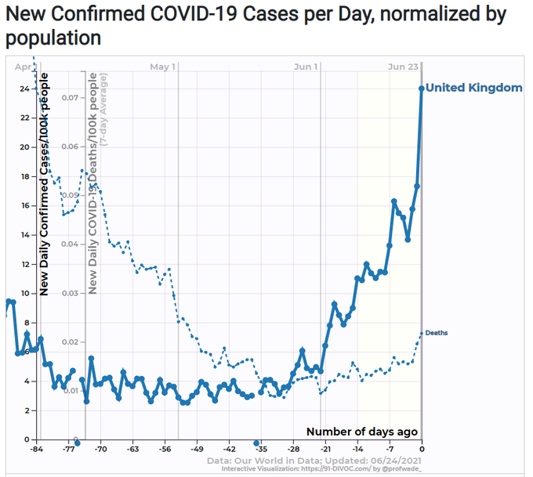

Doctor Malone and I are hardly alone in questioning the safety of the current vaccines.

Tess Lawrie analysis of UK Yellow Card system concluded that the vaccines were unsafe for use in humans. Tess is a highly respected evidence-based expert. 20th update on Adverse Reactions to the Covid Vaccines shows 949,287 Adverse Reactions & 1,332 Deaths. Whoa. The UK has only 67M and 62% have been vaccinated, so that’s around 40M vaccinated people. So that means there an adverse reaction for every 42 people. But since it is likely under reported, it is probably like 1 adverse reaction for every 20 people. Ouch.

This op-ed in the Wall St. Journal on June 22 questions vaccine safety. This statement published in BMJ:

We are part of a group of clinicians, scientists, and patient advocates who have lodged a formal “Citizen Petition” with the United States Food and Drug Administration (FDA), asking the agency to delay any consideration of a “full approval” of a covid-19 vaccine. The message of our petition is “slow down and get the science right—there is no legitimate reason to hurry to grant a license to a coronavirus vaccine.” We believe the existing evidence base—both pre- and post-authorization—is simply not mature enough at this point to adequately judge whether clinical benefits outweigh the risks in all populations.

The signatories to that petition to the FDA include:

Linda Wastila, BSPharm, MSPH, PhD*†
Professor, Pharmaceutical Health Services Research
University of Maryland School of Pharmacy
220 Arch Street, Baltimore, Maryland 21201, U.S.A.

Peter Doshi, PhD†
Associate Professor, Pharmaceutical Health Services Research
University of Maryland School of Pharmacy
Baltimore, Maryland, U.S.A.

Hamid A. Merchant, BPharm, MPharm, PhD, RPh, CQP, PGCertHE, FHEA, SRPharmS†
Subject Leader in Pharmacy
University of Huddersfield
Huddersfield, United Kingdom

Kim Witczak
President/Co-Founder
Woodymatters
Minneapolis, Minnesota, U.S.A.

Peter Aaby, MSc, DMSc†
Head of Bandim Health Project, Guinea-Bissau
University of Southern Denmark
Copenhagen, Denmark

Christine Stabell Benn, MD, PhD, DMSc†
Professor of Global Health
University of Southern Denmark
Copenhagen, Denmark

Florence T. Bourgeois MD, MPH†
Associate Professor of Pediatrics
Harvard Medical School
Boston, Massachusetts, U.S.A.

Anthony J Brookes, PhD†
Professor of Genetics
University of Leicester
Leicester, United Kingdom

Byram W. Bridle, PhD†
Associate Professor of Viral Immunology
University of Guelph
Ontario, Canada

Peter Collignon AM, MB, BS(Hons), BSc(Med), FRACP, FRCPA, FASM†
Professor
Australian National University Medical School
Canberra, Australia

Juan Erviti, PharmD, PhD†
Unit of Innovation and Organization
Navarre Health Service, Spain
Pamplona, Spain

Peter C. Gøtzsche, Professor, DrMedSci, MD, MSc
Director
Institute for Scientific Freedom
Copenhagen, Denmark

David Healy, MD FRCPsych†
Professor of Psychiatry
McMaster University
Ontario, Canada

Iona Heath, CBE FRCGP†
Past president of the Royal College of General Practitioners
London, United Kingdom

Matthew Herder, JSM LLM†
Director, Health Law Institute
Dalhousie University
Nova Scotia, Canada

Tom Jefferson, MD MRCGP FFPHM†
Senior Associate Tutor
University of Oxford

Robert M. Kaplan, PhD†
Distinguished Research Professor
UCLA Fielding School of Public Health
Los Angeles, California, U.S.A.

Ulrich Keil, MD, PhD, FRCP (London)†
Professor Emeritus
University of Muenster
Muenster, Germany

Joseph A. Ladapo, MD, PhD
Associate Professor of Medicine
David Geffen School of Medicine at UCLA
Los Angeles, California, U.S.A.

Donald W. Light, PhD†
Professor of Comparative Health Policy and Psychiatry
Rowan University School of Osteopathic Medicine
Glassboro, New Jersey, U.S.A.

Peter A. McCullough, MD, MPH†
Professor of Medicine
Texas A & M College of Medicine
Dallas, Texas, U.S.A.

Barbara Mintzes, BA, MSc, PhD†
Associate Professor, School of Pharmacy
The University of Sydney
Sydney, Australia

Huseyin Naci, MHS, PhD†
Associate Professor of Health Policy
London School of Economics and Political Science
London, United Kingdom

Allyson M Pollock, MBChB, FRCPH, FRCP (Ed) FRCGP†
Clinical Professor of Public Health
Institute of Health and Society, Newcastle University
Newcastle upon Tyne, United Kingdom

Angela Spelsberg, MD, SM†
Comprehensive Cancer Center Aachen
Aachen, Germany

Erick Turner, MD†
Associate Professor of Psychiatry
Oregon Health & Science University
Portland, Oregon, U.S.A.

Patrick Whelan, MD PhD†
Associate Clinical Professor of Pediatrics
David Geffen School of Medicine at UCLA
Los Angeles, California, U.S.A.

I know several of the signatories very well and they will tell you straight out that they go further than just saying “pause so we can collect data on safety.” They believe these vaccines are unsafe and should be stopped. The WSJ op-ed and citizen petitions are an academically polite way of raising a red flag to say “STOP” and do the science right. And when you do look at the data as they requested, you will be appalled at what you find. There is no doubt of that as you will see below.

In this article, I will not tippy toe around the facts: we should stop these vaccines immediately. Even for the elderly, early treatment with repurposed drugs is a superior option to vaccination.

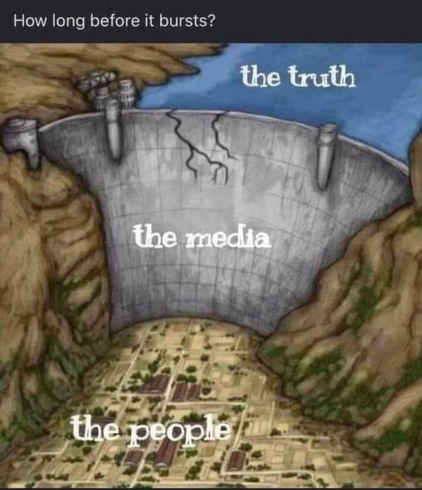

The normal stopping condition of 25 to 50 deaths was exceeded in January 2021. Once the vaccines are stopped, if anyone gets COVID in the interim, they should be treated early with a repurposed drug protocol until safer vaccines (not gene-based) are available (see Vaccine FAQ for some recommended protocols).

We are way past any reasonable stopping condition. There is no question that this vaccine is killing people… likely more than 30,000 people so far, and they are just getting started.
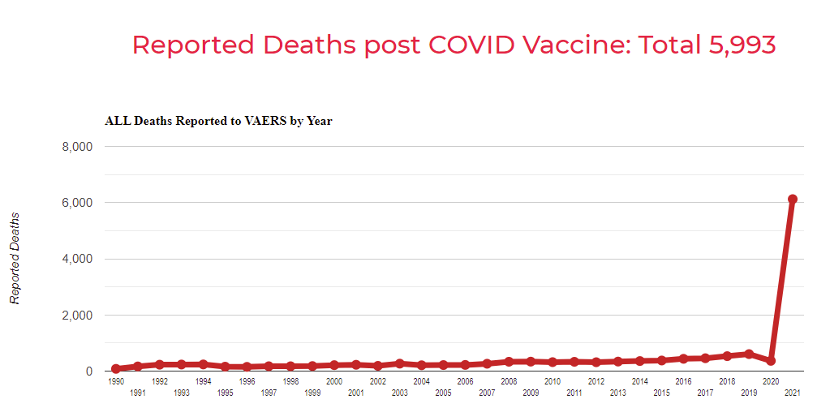
From the chart above (which can be viewed here), it appears that this vaccine is only 12X as deadly as other vaccines. This is not the case. The 300 to 500 deaths each year are essentially background deaths of people dying in temporal proximity to a vaccination; the actual number of people who die each year from the vaccines is around 10. So if we take 6,000 deaths minus 500 background, we get 5500/10, so this vaccine is more than 550 times more deadly than a typical vaccine should be.

The biggest blunder is that the FDA and drug companies assumed that the spike protein was a harmless antigen. Some people even still believe that to be true. But that is clearly false; it is the spike protein that causes the bleeding, micro-clotting, and inflammation leading to death for COVID victims. Therefore, any vaccine which enables the spike protein to be produced in parts of your body other than your shoulder is extremely problematic. All the gene-based vaccines do that.

Even more importantly, the vaccine is turning healthy kids into (likely) permanently disabled brain-damaged kids because the neurologists all believe the vaccine is safe so they don’t look for or consider the inflammation and micro-clotting which they can’t see in MRIs. The kids are then not treated leading to permanent scarring and loss of function. It’s tragic.

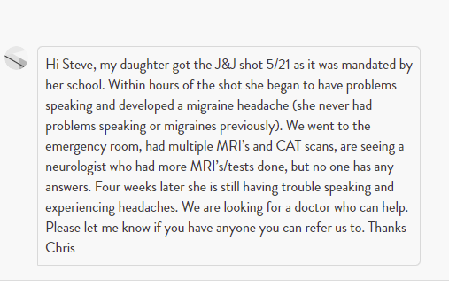

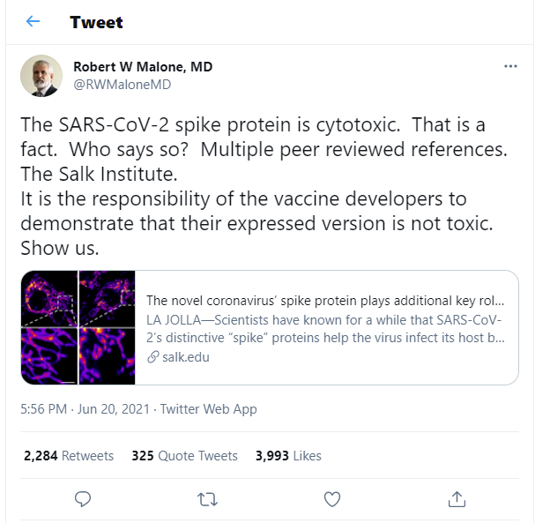
The FDA knew that the biodistribution data on these vaccines would deliver the lipid nanoparticles (LNPs which contain the mRNA) to all parts of the body. But since they thought the spike protein was harmless, this wasn’t a cause for concern. Now that assumption was proven wrong, it should have sent alarm bells ringing. The drug companies should have been required to immediately do toxicology studies in NHPs and the amount of bound spike and free spike should have been measured. Of course, nothing of the sort ever happened because the FDA and CDC are all focused on reducing vaccine hesitancy, not safety.

This means that the CDC is basically flat out lying to the American people in order to fool them into getting vaccinated. This isn’t open to debate. It is right on this page:

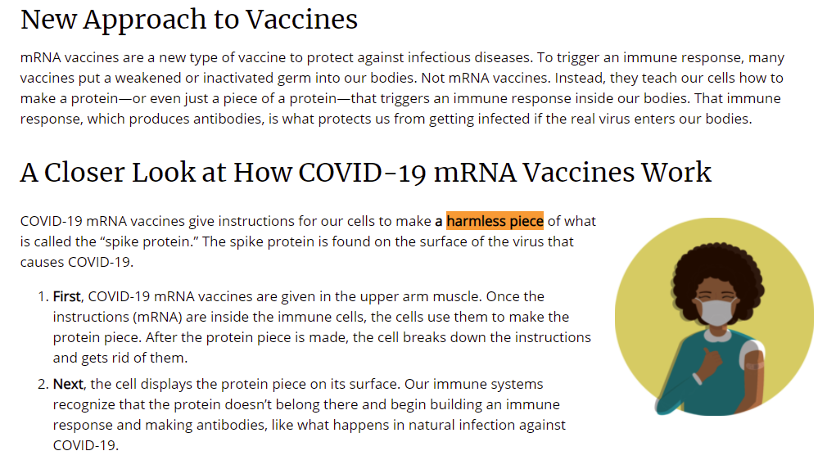
My key arguments are:
- Fundamentally, the whole problem with the vaccines is blind trust in authority.
- I am pro-VAX in general. My entire family got jabbed. However, over the past few months I discovered to my horror that the current FIRST generation gene-based vaccines are UNSAFE for use in humans. Next generation vaccines, such as Novavax, based on traditional technology (where the antigen is pre-manufactured) are MUCH MUCH MUCH safer, but are being blocked from the US market by the FDA so that Moderna, Pfizer can maintain their virtual duopoly.
- To prove nobody can prove the vaccines are safe, I offered to bet anyone $1M who can prove that the vaccines are safe. To win the bet, they simply have to show that that 5,000 deaths reported in VAERS are all unrelated to the vaccine.
- Even the WHO said on June 22 that “Children should not be vaccinated.” (see proof below). Just 48 hours later, they walked it back. What new evidence was published in peer reviewed journals to cause that? None. They cited no reason for the about face. The US is ignoring the WHO June 22 advice and going full steam ahead to vaccinate everyone. If the vaccine is perfectly safe, why did the WHO say not to vaccinate kids? (search for the phrase “Children should not be vaccinated” below).
- If the vaccines are perfectly safe, this site (c19vaxreactions.com) would not exist. Please watch the videos on this site. Does this sound like a safe vaccine? Maddie’s video is there.
- We know that the vaccines are not as safe as the clinical trials claimed. So the argument about safety is simply not true. Consider the case of Maddie de Garay age 12. She was in the Pfizer clinical trial. She’s paralyzed from the waist down after the second shot. According to the trial report, she was listed as reporting “abdominal pain.” The EUA should be revoked based on this revelation. This is not an isolated case.
- On June 24, 2021, the FDA finally admitted that the vaccines are not as safe as they claimed and cause myocarditis and pericarditis.There were more than 1,200 cases among the 150M vaccinated people. I can guarantee you that this will not be the first revelation. So how do they explain how such a safe vaccine with a harmless spike protein (as noted in the CDC snippet above) can cause myocarditis? Well, they don’t. But we know how it happens and myocarditis is just the tip of the iceberg.
- The current gene-based vaccines were rushed to market, did not undergo the proper testing and dose escalation studies, are dangerous because 1) the spike protein isn’t harmless (causes inflammation, clotting, and damage to endothelial cells) and 2) the spike protein breaks off creating free spike which can damage organs anywhere in the body including the brain and heart (stroke, heart attack, etc). It opens the blood brain barrier causing severe migraine headaches.
- The current gene-based vaccines cause spike protein to be made in all major organs including your brain and the spike protein is now known to be toxic. That is no longer open to debate, even if some people still don’t believe it (including the CDC). The people who think it is harmless cannot explain over 300,000 adverse event reports and over 6,000 death reports in VAERS. The rate of adverse event reporting is so high it is overloading the reporting systems.
- Vaccines should have been stopped when the death toll rose over 50 in January 2021. That is the normal stopping condition for a national vaccine. For child deaths, 4 is the threshold.
- Today, the absolute risk of dying from the vaccine itself is approximately 1 in 5,000 (150M fully vaccinated and 5*6,000 in VAERS deaths; see below for calculation of the 5 factor). The risk of dying from COVID is about 1 in 8,000 (1.2% chance of catching COVID based on population of 328M and 11,000 new cases/day and a 1% chance of dying from COVID which is very conservative based on the .1% rate of death from the UK data below). This isn’t a compelling case for vaccination because it is clear that you have a better chance of living if you do not get vaccinated! Also, it doesn’t take into account that if you are vaccinated your risk of dying from COVID is 2X higher for the delta variant (see calculation below), and there is risk of disability as well from the vaccine. And this is without ANY prophylaxis or early treatment which skews the benefit even more (by a factor of more than 416 as we explain below)
- If you don’t believe the previous point, consider this alternate argument: UK data shows that vaccinated people are 2.2 more likely to die from the Delta variant of COVID than unvaccinated people. That’s right… getting vaccinated actually increases your chances of dying from COVID if you get it. Think about that before you get vaccinated. But don’t worry because the FDA says the benefits outweigh the risks. Please see the data below for the detailed calculation (search for “Justification for 2X higher death rate for vaccinated people in UK against Delta variant”). However, your chance of getting COVID is reduced by a factor of 3. I work out the math at the end and the UK will basically kill over 6,000 people today in order to save around 80 net lives per year. So we’ll break even in about 75 years from now. I’m not joking. And if you treat infected people early, then it stretches the breakeven point to over 1,000 years from now (basically more than an order of magnitude since early treatment is 10X relative risk reduction or more...it’s actually around 416X when done using Fareed and Tyson’s protocol).
- This peer-reviewed paper looked at the real cost-benefit analysis and concluded that “This lack of clear benefit should cause governments to rethink their vaccination policy.”
- If the pathologists doing the autopsies don’t understand how the vaccine kills people or believes the vaccines are safe, then nobody will have the vaccine listed as the cause of death. Accurate database entries are only as good as the judgement of the reviewers and right now the entire medical community thinks the vaccines are flawless.There isn’t even a CDC category for death caused by the vaccine.
- The biggest failure with respect to vaccine victims is that the vaccine manufacturers have miserably failed to educate the medical community on the dangers of the spike protein, the mechanisms of action for how the vaccine causes death and neurological side effects. For example, one 12 year old vaccine victim (participant in the Pfizer clinical trial), became permanently disabled less than 24 hours after her second dose of Pfizer (cannot walk, requires feeding tube, she currently cannot go to the bathroom without assistance, etc) was diagnosed with mental problems because doctors lacked a conventional explanation for her symptoms. Her story is tragic and sadly not an isolated case. Pfizer hasn’t paid a dime in compensation for her permanent disability.
- Moderna sent mRNA coronavirus vaccine to University of North Carolina in an agreement signed December 12, 2019 which was more than two weeks before anyone was aware of the outbreak at Wuhan. How did Moderna know to develop a coronavirus vaccine so early!?! Doesn’t anyone else think that is pretty odd? Why isn’t the press all over this?
- The FDA has top experts who have looked at all the safety signals and conclude there is nothing to worry about. Just one problem: they refuse to make any of these reports public. Why not? Wouldn’t that eliminate vaccine hesitancy? The press isn’t asking this important question. Asleep at the wheel.
- Due to reports by parents, on June 23, the FDA finally had to admit, “ok, we were wrong. It wasn’t as safe as we told you. There is a tiny chance that you’ll have heart problems if you are vaccinated.” Hardly tiny. Hardly the only side effect but at least we are moving in the right direction.
- Kids and people who have had COVID don’t need to be vaccinated. They are already immune. Details below.
- The CDC refuses to even admit to a single death due to the vaccine. All of these deaths are simply coincidences. They don’t even have a category defined to track deaths caused by the vaccine! They will not disclose the number of people who have been killed/disabled by these vaccines. There is evidence it could be over 25,000 based on multiple ways of estimating the number
- The FDA never set a stopping condition for the COVID vaccines.
- This whole vaccine stuff is completely stupid. If a drug is 50% effective and used by 70% of the population it would stop the virus. Using ivermectin as a prophylactic would do it. Dr. Malone is working with a small country to prove this works.
- Nobody is analyzing the deaths reported in VAERS. If the 6,000 deaths reported in VAERS (half of which were within 3 days of getting the vaccine) were not vaccine related, then how did those people die? If you look at previous years, hardly anyone 20-30 years of age will die… A VAERS search will show maybe one death, NOT related at all temporally from a vaccine. But the same search in 2021 yields 58 records (as of June 21, 2021). If this is a perfectly safe vaccine, how does the CDC explain that? Well, they don’t. And the press won’t ask them either.
- The V-SAFE database is kept secret. Why? Could it be that they don’t want anyone to see how dangerous the vaccine really is? Doesn’t seem to be much transparency here, but nobody will risk speaking out (except me and others who have to remain anonymous for fear of retribution). Why aren’t the academics outraged about this? Of course some are, but no leading academics will dare speak out or their NIH funding will disappear. Instead, the CDC simply releases snippets of info that they deem to be relevant. Death data? Not interesting to anyone of course!
- The VAERS database started showing an unambiguous safety signal in January 2021 (as noticed by friends of mine including Jessica Rose who is highly respected), but nobody in the CDC or FDA was paying attention. Anyone doing a search for ages 20-30 this year will find over 50 deaths. In prior years you’d be lucky to find one death. How does the CDC explain that? Plus, half of the deaths occur within 3 days of the vaccine. If the vaccine isn’t causing these deaths, what is?
- This paper is a smoking gun (only if you are a scientist because most other people won’t understand). How does the CDC explain this? The press never asks them. Nobody wants to look at the facts.
- Here’s another paper showing several cases of unusual thrombotic events and thrombocytopenia have developed after vaccination. If these vaccines are perfectly safe, then how do you explain all these cases? Bad luck?
- There is no informed consent as required by law since test subjects have not been informed of the risk of death, disability, and other side effects. They have also not been informed of the absolute risk reduction and the efficacy of alternatives.
- The BSL-3 labs are currently booked up doing animal studies for the vaccines; these are studies that were supposed to have been done before the vaccine rollout! So companies like Linear Therapies which are working on antivirals cannot test their drug.
- The absolute risk (AR) of getting COVID is currently <1% per year based on current case rates. So the absolute risk reduction (ARR) of a vaccine is a fraction of this. Your AR of dying is thus now around 0.01%. The vaccine’s ARR is always a fraction of the absolute risk. Is a vaccine which could kill or permanently disable you worth it, especially when there are better alternatives available? Of course not! Why isn’t the CDC informing anyone of the benefits and risks of the vaccines and alternatives?
- There are safer alternatives than the current vaccines to prevent COVID deaths: prophylaxis, treating early with repurposed drugs, and waiting for safer vaccines that are not gene based.
- All of BARDA’s funds for early treatments were repurposed so no early treatments were funded. They directed funds to something that was guaranteed not to work: using an antiviral like Remdesivir after it is too late for an antiviral to work.
- Virology 101: You cannot vaccinate yourself out of an RNA-based upper respiratory based virus. When you put positive pressure on an RNA-based virus that can mutate with a non-sterilizing vaccine, they adapt to it. It’s guaranteed. This is what the UK, Bahrain, and other countries are learning now.
- Early treatments work with lower risks and greater benefits than any vaccine. The work of Fareed and Tyson will be submitted for publication soon showing if people present sufficiently early (when symptoms are still mild), 99.76% relative risk reduction in hospitalization (416X) and a 100% relative risk reduction for death. This beats any vaccine in terms of superior benefit and lower risk. However, since the NIH says early treatments don’t work, doctors don’t pay any attention to these results which can be verified independently by anyone who wants to look. The NIH has no interest in looking because they are not interested in anything except the vaccine. Also, the top journals reject any papers showing early treatments, such as Zelenko’s paper and McCullough’s paper. The reason is that doctors using these protocols are treating patients so they are not DB-RCTs which the journals are more likely to publish. Also, these clinicians using these protocols are not academics who write papers. Brian Tyson has treated thousands of patients, but never has written a paper on it.
- Early treatments have been unethically suppressed and kept from public view in order to promote the vaccine. Ivermectin and fluvoxamine have both been proven in the top-levels of evidence based medicine (large randomized trials and/or peer-reviewed systematic review) yet NIH does nothing and Congress isn’t asking any questions so they get away with it. Now the government is spending billions on a Merck drug that might be proven someday. Why aren’t they spending billions to promote the drugs we have now that are proven to work early? Interferon Lambda works extremely well early. GS-441524 has been shown to be a very effective generic RNA antiviral yet there is no investment in that drug despite superior safety and efficacy. This drug was extensively studied by NCATS division of NIH. I know one person who tried it; it miraculously cured her long-haul COVID when nothing else worked.
- FDA, CDC, NIH have violated the public trust by promoting an unsafe vaccine and failing to provide disclosure of the risks and alternatives.
- Newer vaccines have been already shown to be much safer. As of June 19, the safety data for the Novavax vaccine is significantly safer by at least a factor of two or more. Why isn’t the FDA allowing it to be used in the US? Answer: because nobody would take any of the other vaccines if Novavax was made available. Drug company profits in the US are apparently more important than people’s lives.
- There is a risk of ADE which is never disclosed to vaccine recipients. This should be disclosed. In short, the vaccine may make it more likely that people are infected with COVID. This is what is happening in Bahrain for example, where the case rate and death rate went up by a factor of 10 after vaccination was rolled out.
- Here’s a video from the Stew Peters Show explaining hundreds of people with diagnosis of Guillain-Barre syndrome (which is ultimately fatal) from the vaccine as well as an explanation why people are magnetic after being vaccinated.
- Half of healthcare workers have not been vaccinated. We will need them not to be vaccinated so they can care for the vaccination victims.
- Four British Airlines pilots died within 1 week of getting the vaccine. BA says the deaths were not related to the vaccine, but they provide no evidence of that claim. We have offered to have Robert Malone, MD examine the medical records of the pilots, but BA has not responded. There are approximately 3,600 vaccinated pilots and 4 deaths which is a death rate of over 1 in 1,000. That’s not easy to explain. How can four drop dead in a week from getting the vaccine? One death is bad, two in a week is hard to believe… four deaths and they ALL had the vaccine. Similarly, at least 3 Delta pilots died shortly after getting the vaccine, but NOBODY is allowed to examine the medical records. Are they hiding something? (there are 14,000 Delta pilots so the BA numbers are a lot more significant). These are deemed to be all coincidences according to the airlines who are being totally opaque with the facts. They never explain how they know the deaths are not related to the vaccine. BA will not say anything about the vaccination dates of the pilots and the death dates. Why not disclose that? We know from other sources that all four were vaccinated. I contacted the BA press center who were responsive until I asked for the vaccination dates of the four pilots. Then they stopped responding. Weird. Watch this video for more information.Highly recommended. Also a cargo pilot passed out on the runway in Canada and had to be taken out in a stretcher. What do you bet that that pilot was vaccinated as well?
- The argument that the vaccines are unsafe are not based on any single piece of evidence. Indeed, it may be possible to discredit each and every piece of data. It is the sheer number of different methods (including mechanism of action matching observed side effects) that creates a compelling picture that is impossible to ignore.The prima facie evidence is crystal clear and it holds up under detailed scrutiny.
- Academics who rely on the phase 3 studies as proof of safety are going to be very embarrassed. What was reported isn’t what actually happened. I’ll reveal this later after we file the requisite paperwork. So let’s leave this one as a placeholder for now.
- Mainstream media continues to ignore all this evidence. My PR agency has pitched them all and most of them will not even look at this document. However, we found one reporter who invested the time and the more he looked, the worse it looked for the CDC, FDA, NIH, ...story coming soon.
- Any academic institution who defends the vaccination program should be asked before the debate: “How much funding does your institution get per year from the NIH?”
- Any Democratic committee chairman can write a letter to the NIH to request Fauci’s unredacted emails which would reveal the true source of the coronavirus. Nobody has despite repeated requests. Why is that? It’s because Congress does not want to show the world that Tony Fauci, who they trusted, not only funded the creation of the coronavirus, but then covered it up when it leaked out. The press isn’t asking them why they aren’t requesting the emails since it would unambiguously show what happened.
- Nobody prominent will debate Malone and me. The perfect way to end vaccine hesitancy is to bring us down. What are they scared of? Pfizer was invited by TrialSiteNews to debate us but declined because they didn’t have any available resources. They wrote, “As you could imagine, we have had a massive volume of media requests at this moment and our scientists are incredibly busy. Unfortunately, we are not able to accommodate your request at this time and must decline this opportunity.” So, maybe someday they will have time to address the important question of vaccine safety.
- Podcast by Drs Bridle and Malone. The smear campaign against Dr Bridle in Canada has been totally unwarranted. His critics take to social media rather than engaging in fair open scientific debate because they know they cannot win the latter.
- Even if you think the current vaccines are safe, then you still must contend with the arguments of Geert Vanden Bossche, one of the most famous scientists in the vaccine field, which are further clarified in this excellent video by Chris Martenson which points out that there are really only two ways out of the pandemic: a sterilizing vaccine (using the complete virus as the antigen) or allowing infection and treating with early treatment leading to natural immunity. This is something that Chris has also been saying for a year. Because he’s predicting the future, if you want to credibly attack Dr. Vanden Bossche arguments, that can only be done credibly by someone with comparable or higher credentials. Who would that be that can credibly challenge his argument?? Of course, for the current vaccines we can credibly argue with the NIH, etc. since we have the actual VAERS data. However the UK data (shown at the start of this document) shows that Dr. Vanden Bossche was telling the truth.
- Consider this: “Why don’t they make “safer” vaccines, when they could? Because the $50billion vaccine business is the gateway to the even more lucrative “treatment” drug business for the very chronic illnesses listed on the vaccines inserts—- the vaccines engineer the market for the $500 billion juggernauts: the auto immune, asthma, allergy, seizure, etc., meds made by the same players. It’s the biggest business model there is: Shot and pilled from cradle to grave.” This is a somewhat cynical view that I used to categorically reject. But now I’m not so sure it isn’t correct.
- Let’s not forget the role of the social networks, wikipedia, and especially YouTube in all this. Not only do they censor the early treatments that could save people’s lives and remove vaccine side effects groups of hundreds of thousands of people, but they also censored videos on the medical community censoring doctors and scientists like this video which was censored from YouTube that featured Dr. Byram Bridle and MP Derek Sloan.
- The President of Stanford asked the Dean of Medicine to discuss Stanford’s mandate to vaccinate students. Marc Tessier-Lavigne is to be commended for this.
- Finally, this list would not be complete without watching this clip from The Late Show featuring Jon Stewart (start at 2:53) explaining the true origin of the coronavirus in a way that everyone can understand. But Stewart wasn’t joking and he deserves a lot of credit for doing this.
- The fact that the current vaccines are super dangerous is not debatable. In just two doctors I know, there have been three vaccine deaths in 1,500 patients. A dangerous vaccine would kill more than 25 people in the entire country. The fact that I know two docs with 3 deaths (more than 10% of total cases) suggests that the numbers are huge.

Here are key resources that provide evidence that the vaccines are unsafe and should be stopped immediately. More and more evidence gets revealed every day. The response from the other side: crickets. Nobody who is prominent that supports the false narrative that these vaccines are “safe and effective” is willing to debate any of us, including Dr. Robert Malone, the inventor of the mRNA vaccine.

Safe and Effective? (video)
This 90 minute video shows you how you can access US government databases to convince yourself that over 25,000 people have been killed by the COVID vaccines. So even if you don’t believe the 5X multiplier, it still doesn’t matter since we are way over the stopping condition. They are supposed to halt the experiment after 25-50 lives have been lost. There is no stopping condition for this vaccine. They can kill 100,000 Americans and still vaccinate people.

Safe and effective? (slides)
These are the slides from the 90 minute talk. The talk does live web browsing so this is just a subset of the material in the talk.

Malone bioethics article on TrialSiteNews
This article, written by the inventor of the mRNA vaccine, should frighten any sane person.

Darkhorse interview with Malone and Kirsch (3.5 hours)
This is a 3.5 hour video with 635K views and 27,000 likes with mRNA inventor Robert Malone and me. I know a lot of people who have watched this video three times. It’s that good. It used to be on YouTube, but they removed it for violating their community standards.

Byram Bridle paper
This is the paper that started it all. Dr. Bridle did a FOIA request of the Japanese government to get a Pfizer document. To his surprise, it showed that the vaccine does not remain in the deltoid muscle (like other vaccines) and it shows that the S1 subunit is toxic. The lipid nanoparticles (LNP) deliver the mRNA to cells all over the body including inside the heart, brain, and ovaries leading to the manufacture of toxic spike proteins inside these organs causing inflammation and blot clots all over the body leading to a variety of side effects including permanent disability and death. Free S1 can also open up the blood-brain barrier temporarily causing severe headaches. Here is what Robert Malone said about Dr. Bridle after meeting him, “I was very, very impressed by Dr. Bridle. Just a solid scientist, excellent communicator, and all around good guy. A real testimony to all that is good about Canadian academic culture, and he is being vilified.”

Tess Lawrie analysis of UK Yellow Card system
Tess Lawrie, a highly respected expert on scientific evidence who produces reports for the UK government, analyzes the UK version of the VAERS system and concludes unambiguously that the current gene-based vaccines are unsafe for use in humans.

VAERS data analysis by Jessica Rose (YouTube video)
The VAERS database has been screaming to be heard since early January. This expert review of the data has never been challenged. It shows that the vaccine is more deadly than all of the 70 vaccines over the 30 years combined. The signs in the database of a problem are unmistakable.

A Report on the U.S. Vaccine Adverse Events Reporting System (VAERS) of the COVID-1 9 Messenger Ribonucleic Acid (mRNA) Biologicals by Jessica Rose
Analysis suggests that the vaccines are likely the cause of reported deaths, spontaneous abortions, anaphylactic reactions and cardiovascular, neurological and immunological AEs. The precautionary principle promotes transparency and the adoption of preventative measures to address potential risks to the public in the arena of vaccination programs, and it is vital that individuals are informed of these potential risks before agreeing to participate in any medically involved treatment program.

Should you get vaccinated
This is a detailed analysis of the data by CETF Executive Director Steve Kirsch. It talks about the science, the data, why doctors are blind to reporting the problems, and who is responsible for the virus and suppressing the approval of repurposed drugs despite clear evidence they work. The short answer to the question, “should you be vaccinated” is absolutely not with the current vaccines.

Peter McCullough calls for stopping vaccinations for anyone under age 30
In this Fox News segment, Dr. McCullough describes the risks of the vaccines and calls for a halt of these vaccines for anyone under age 30.

Legendary Epidemiologist Sucharit Bhakdi on the Covid Vaccine
Sucharit Bhakdi warns the world about the dangers of the vaccines including blood clots.

Paper written by a scientist at a top institution opposing vaccinations (for opposing employer mandates)
This paper was written by a scientist at a top research organization who opposes vaccinations. He makes a compelling case with new arguments. Name withheld at his request for fear of retribution.

NEJM Letter to Editor pointing out error in spontaneous abortion calculation
The authors of this paper show clearly that based on the data currently available, there is >82% spontaneous abortion rate at <20 weeks for vaccinated women. This number will go down as more pregnancies complete and the data is released. But the data today is absolutely alarming. The key point isn’t the >82% rate. The key point is we don’t know what the number is because nobody has the data and it shows that the CDC is pushing the vaccine on pregnant women even before the safety data is available! This has never happened before. In the past, we’ve always had to prove an intervention is safe BEFORE we recommend it to pregnant women. The authors are correct in their calculation; they are currently negotiating with the NEJM to accept their LTE. NEJM basically told the authors that the paper was “incorrect” and that they are declining it. But there is no error. This has been checked and double checked. If NEJM doesn’t do the right thing, they will tarnish their reputation (as well as endanger the lives of unborn babies). I personally know of two anecdotes with pregnancy and the vaccine, and both are very negative. One woman got vaccinated shortly after conception. The baby had no heartbeat. Another woman got vaccinated at 20 weeks and 17 weeks. Her baby was so badly disfigured that her gynecologist had never in her career seen anything like it. So reality seems to suggest that the paper is right. Also, I was on a Dr Drew podcast with Dr. Zelenko, and he independently found the exact same error in the original paper. See also this article on the spontaneous abortions reported into the VAERS system.

Skipping of testing on on teratogenicity, oncogenicity, and genotoxicity in COVID-19 vaccine development
They skipped all testing on teratogenicity, oncogenicity, and genotoxicity in COVID-19 vaccine development. The FDA and PHARMA believed it was dangerous to pregnant and childbearing potential women so excluded them and justified it with IRBs during the randomized trials. It is public agency malfeasance and individual malpractice to recommend or participate in the injection of untested active, dangerous biological agents in the bodies of pregnant women.

Dr. Hoffe letter to Dr. Bonnie Henry
Dr. Hoffe’s is a respected physician in Canada. His hospital privileges were revoked after he wrote this letter expressing grave concern about the safety of the vaccines. He has only 900 vaccinated patients and one death due to vaccination. All his adverse event reports were discarded. He has not been heard from since. Why would a physician risk his livelihood if he wasn’t telling the truth? Ask yourself, why would he write the letter in the first place if the vaccine were perfectly safe and effective? He has no history of alarmism. While this is an anecdote, he is hardly alone as the VAERS data tells us so clearly. Please watch this video of Dr. Hoffe. He trashed his entire career when he spoke the truth. He certainly has a legal cause of action against the hospital. Read his letter. Watch the video. Look at the VAERS data. Then you decide who is telling the truth.

Austin Walters paper showing 25,000 unidentified deaths which started when the vaccines rolled out
This paper was written by an engineer who discovered the CDC death database (which is not voluntary) showing 25,800 unexplained deaths. This suggests that VAERS could be under-reported by at least a factor of 5 (since heart attacks, stroke, and other causes of death are not counted in the “unidentified” deaths). In the recent past, these uncategorized deaths have been reclassified into diseases of heart (#1) and COVID-19 (#2). So there is no proof that these are all vaccine deaths, but they could be. Analysis by state shows states like AL where vax rates are low have few excess deaths whereas states like CA with high vax rates have high excess deaths.

Tweets by WelcomeTheEagle88 (Albert Benavidez)
Alberto has been sounding the alarm since early January that the vaccines are unsafe based on the VAERS data. Nobody was listening (he only has 439 followers). But the information was in plain sight for all to see. His tweets are proof that others saw the problem in January. What were the FDA and CDC doing that they missed this?

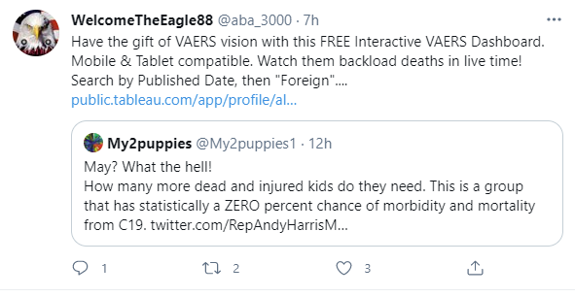

2,400 Covid-19 Vaccine Deaths Occurred in First Six Weeks of Program, CDC Back Loading Data
Paper showing VAERS data documents the CDC under reported injuries by 89% for the first six weeks of Covid-19 vaccination program & deaths by 73%. The public must immediately DEMAND release of all available VAERS injury reports and immediate inclusion of all report submission dates.

Brigham/Harvard paper of vaccinated nurses showing free S1
Shows that the S1 subunit cleaves off and becomes free S1 in vaccinated patients. This was never supposed to happen. Free S1 can not only cause inflammation and clotting anywhere, but it also can open up the blood brain barrier to invaders leading to severe migraine headaches which explains why some people have severe headaches after being vaccinated..

Vaccine FAQ
Common Q&A on vaccine side effects. Answers questions like “Can you get headaches, menstrual problems, and myocarditis by hanging around vaccinated patients?” or “Are vaccinated people more likely to die from blood clot on a plane?”

If you are suffering from vaccine side effects or long-COVID, the Vaccine FAQ document has the drugs that are proven to alleviate the inflammation that may be causing your problems. Reducing inflammation using drugs that work against the spike protein-induced inflammatory response is a good starting point.

CDC database 202-2021
Here is the original CDC data where you can view the original data.

CDC data imported and analyzed (excel spreadsheet)
Excel spreadsheet of CDC database showing how to calculate the 25,000 excess deaths

OpenVAERS
This is the OpenVAERS database used in the video. It is a user-friendly front end to the official VAERS database. Here you can see that half of the deaths happen within 72 hours of the vaccine (look at the bottom left of this page).

If you can prove that the NIH and WHO got their treatment guidelines right, you could win $2M
A $2M reward was offered to anyone who could show that the NIH recommendations made sense. No takers. Shows that nobody can defend the ridiculous recommendations of the NIH for fluvoxamine and ivermectin. This shows corruption at the very top levels of the NIH; they were sandbagging the recommendations for ivermectin and fluvoxamine despite compelling data. They did this so that they would be able to justify an EUA for the vaccine since no other treatments were available. Duh

How VAERS works
A description of the VAERS system and how it works.

People who have had COVID do not benefit from the vaccine
"The study findings reveal that individuals with previous SARS-CoV-2 infection do not get additional benefits from vaccination" This has got to be very embarrassing for the CDC.

Kids are naturally immune to COVID
Even if the vaccine were perfectly safe, kids and those who have already had COVID should not be vaccinated. Both are already immune to a greater extent than the vaccine would provide. so vaccination is pretty silly; it would be like doubly vaccinating someone.

What happened in Singapore (antibody response to syncytin-1 is real and harmful)
Mike Yeadon and Dr. Wolfgang Wodarg raised an alarm in Item XI of their petition to halt the Covid vaccine in December that it may induce an antibody response to syncytin-1, which is essential for placenta formation. The Singapore study authors set up their study to “dispel” this insinuation by performing calibrated semi-quantitative ELISA tests on 15 female healthcare workers at the National University of Singapore Hospital who received the Pfizer vaccine. Their goal was to show that the Pfizer vaccine DID NOT caused the worker’s blood plasma to display an increased binding to syncytin-1.

Instead it showed that the vaccine DID cause an increase. EVERY single one of the 15 subjects showed a measurable increase in plasma antibody binding to syncytin-1 after the Pfizer vaccine.

The problem is that the authors didn’t like what they found, so they asserted that their result was not “significant.” It’s impossible to explain why this statement is false without describing how the test the authors used works, so Brian Mowrey made the article to explain the testing system and why the result the authors study found is a giant warning that the fears they were trying to dispel are valid.

CDC should collect more data, not less
The Economic Standard believes the CDC should be collecting more information, not less. They find their behavior perplexing.
Note from Bahrain
This note from Bahrain, published at TrialSiteNews. Worth reading about forced vaccinations there. Here is an excerpt: “In Bahrain, COVID cases before the vaccines were in the range of 300 cases and 3-5 deaths a day. After mass vaccination, it reached more than 3,000 cases and 30 deaths a day. Many witnesses -including people I personally know- speak of loved ones who have died after getting the vaccines however young and healthy they were prior. If you go to social media accounts you can see hundreds of stories from all around the GCC about death cases, however, the government never ever says this is due to vaccines. One time, the government in Bahrain said that a number equals to 16% of that day's death cases were vaccinated with both shots, later they removed it. Another time they admitted that 10% of deaths from January until end of May were vaccinated with both shots. It is worth noting that they consider people who have received one shot NOT vaccinated.”

Anti-Vaccine Activists Use A Federal Database To Spread Fear About COVID Vaccines
NPR published this article. I’ve challenged him to a public debate. He did not respond.

COVID-19 vaccines not safe for human use
Article by Dr. Peter McCullough argues that data from the US and UK both make it crystal clear that the vaccines are unsafe for human use. He points out that the CDC is still insisting that none of the deaths have been attributed to the vaccine, “While the CDC has stated twice on their website that none of the deaths were caused by the vaccine, without external unbiased safety mechanisms including critical event committee, data safety monitoring board, and human ethics board, interpretation of the CDC causality claim can only be made in the context of semantics.”

Precautionary Principle of medicine
This is the principle to use in a pandemic for evidence and for harms caused by the vaccine. The idea is you always make decisions that minimize death if you aren’t sure of the evidence. So if VAERS is flashing red, the precautionary principle says stop the vaccines.

Using all the available evidence
This is an excellent article by Norman Doidge. Should be required reading for the medical community.

Ivermectin systematic review published (June 19, 2021)
It can no longer be said that there are no early treatments. Ivermectin now has a peer-reviewed systematic review that it works. There is now a safe alternative to vaccination.

RCT in India shows 80% reduction in mortality using natural supplements
A recent study in India showed a 80% reduction in mortality by using certain natural supplements. The site c19early.com also documents 10 repurposed drug/supplement treatments each with 50% or more relative risk reduction. Every single one of these have been ignored by the NIH so that people would think that early treatments don’t work.
COVID-19 Spike Protein ELISA (ELV0COVID19S2)
For testing pathology samples, fill out the Testing Service Quote Request Form.

Seven ways we get a 5X multiplier of the VAERS death data
None of these methods is bulletproof and I don’t claim they are. But all the methods are independent and they all point to approximately the same result of a death rate from the vaccine of approximately 1 in 5,000 fully vaccinated people (30,000 deaths so far or 5X the VAERS reported number).
- Austin Walters paper. Here’s the spreadsheet I made. Note:the excess deaths have NOT been re-categorized yet, so this method is speculative. However, there is NO category for death from the vaccine. So all these vaccine deaths will be lumped into other categories like heart attack, stroke, etc. so it will look like no vaccine deaths! It appears these uncategorized deaths are re-distributed into diseases of heart (#1) and COVID-19 (#2). If they only had a “COVID vaccine” category! What is interesting is there are few excess deaths in states with low vaccination rates (like AL) and high excess deaths in states with high vaccination rates (like CA). Thanks to Josh Dudley for pointing this out.
- Estimate from OpenVAERS experts: Liz at OpenVAERS believes the number killed from the vaccines is over 20,000 (when the death count was 5,000)
- CMS database: We ran the same query on VAERS (voluntary) and CMS (not voluntary). The CMS database was 5X higher in terms of number of records returned for the same query. This suggests a 5X factor of under reporting in VAERS. The CMS database is not publicly available but anyone with access to it can verify the query.
- Physician reports: We surveyed physicians with over 5,000 patients and got 2 vaccine related patient deaths (and one employee death). This suggests a much higher death rate of 1 in 2,500. 1 in 5,000 is conservative.
- British Airways Pilot data: There are approximately 3,655 vaccinated BA pilots (85% of 4,300). Four pilots died shortly after getting the vaccine. Even if just one of the four is vaccine related, that is one death in 3,655. Pilots NEVER die like this in the span of a few weeks. Nothing like this has ever happened in BA history as far as we could determine. It is rare for one pilot to die in a year.
- Delta pilot data: There are 3 dead Delta pilots after vaccination. There are 12,946 Delta pilots. [Note: I am looking for the hyperlink to this story ]
- The myocarditis reports ratio. On June 23, the CDC said the 1,226 cases of heart disease in children are nothing to be alarmed about. But if you do a search in VAERS for myocarditis for ages 12-17, you get 140 hits. For pericarditis you get 33 hits. Assuming totally disjoint results, this is a 7X factor of under reporting. And the CDC reports were probably underreported as well

Addressing criticism and feedback of my earlier “Should you get vaccinated?” article that appeared on TrialSiteNews.
hamelinsbest comments:

- I don't see any substantial data pointing towards a very dangerous vaccine. It seems like the benefit still heavily outweighs the risks. I don’t agree with that at all. Vaccines are unsafe after 50 people are killed. This one has no stopping condition. There is no risk benefit calc that I’ve seen showing that the current vaccines have benefit>risk when you take into account the death rate from the vaccine. See in particular the UK calculation I did showing it is stupid to get vaccinated. Avoiding vaccination today is actually less risky, and if you add the huge benefit of early treatment and natural immunity, it’s not even a close call. Please provide your numbers if you disagree. I provided mine. It’s interesting that nobody who claims I’m wrong is showing me their numbers to prove I’m wrong. You can only zero the VAERS numbers if you can show that 5500 deaths are not vaccine related. Good luck on that one. I offered $1M to anyone who could do that, and nobody came forward.
- Some of your claims are not based on any data, instead based on hunches that there is severe underreporting. You have to use what is available. I used 5 different independent methods to find the VAERS underreporting factor. All the methods gave a consistent value of ~5X. I don’t claim it is exactly 5X. I’m just claiming that from the data I had available, a 5X multiplier is consistent and reasonable. Where is your calculation of the “correct” number? I’m happy to substitute your number for mine if it is more accurate.
- Everyone, even doctors, nurses, world leaders, Bill Gates, etc. have taken the vaccine. I presume this is because they believe the benefits outweigh the risks. They have skin in the game. Get real; this is because they are being forced to vaccinate in order to keep their jobs. And despite that, half of all healthcare workers have not been vaccinated. It is a rare person that can calculate the odds correctly based on the data in plain sight. People are getting vaccinated because they trust the authorities. Sadly, that trust is misplaced since the CDC is not showing the risk benefit analysis and still claims the vaccines haven’t killed anyone without proving that by producing the death analysis.
- Very sloppy references to people that are conspiracy theorists in the article. I am referring to people that talk about "gene therapy". You know very well this is the wrong term for mRNA vaccines. I am happy to correct any specific statement that is inaccurate. Can you give me some specifics? You can DM me on Twitter.

Gordon S… comments:

- The core of your piece is about the spike in VAERS reports;, it wouldn't surprise me at all if there were huge numbers of bogus reports going into VAERS. All the reports are verified by HHS. Nobody has ever identified a single record in VAERS that is bogus out of over 1.1M records. Yes, there was one bogus record that we know about, but it was removed.
- Now, to be clear, that doesn't mean the spike in VAERS reports isn't meaningful. I'm definitely open to the idea that it could be. But before citing it, someone (or some team of folks) needs to go through these reports and actually do enough follow up to separate meaningful reports from the chaff. The VAERS reports are a great starting point for figuring out whether there may be a problem with the vaccines, but it's just a starting point. In short, to raise the fact that VAERS is showing an unprecedented spike that needs to be investigated is completely legitimate; but to assert that the spike is prima facie evidence of a huge number of deaths caused by the vaccine is irresponsible and frankly credibility destroying. I don’t agree at all. I’ve examined individual case reports. Half of the death reports are within 3 days of the vaccine. It’s pretty clear when you look at reports of 20 year olds who die the next day that they are related. 20 year olds never die in their sleep. It sounds like you’ve never spent any time looking at the actual VAERS data. These deaths in the cases I’ve looked at are all consistent with the mechanism of action of the vaccine (except in cases where there are too few details). There are about 500 deaths that are not related to the vaccine (these are the “background” deaths since people die all the time), but the remaining 5,500 based on statistical sampling look consistent with death by vaccine to me. Also, the rule is that if you have proximate death to the vaccine that the vaccine should be presumed to be the cause unless proven otherwise. Why is there no CDC analysis of the death reports? Have you asked the CDC instead of just asking me?
- While it's not in TrialSiteNews piece, on your Twitter feed you repeatedly assert 25,800 deaths from the COVID vaccines, but except for one reference to an "inside source", I can't figure out where that number is coming from. Are you simply taking the VAERS number and multiplying by 5 based on traditional estimates of underreporting to VAERS? Since that approach is so obviously flawed, I assume you must have gotten that number from somewhere else, but I can't figure out where. Please explain where your 25,800 deaths number is coming from. That came from the CDC excess uncategorized death analysis. See this spreadsheet. The actual number is now around 30,000 (5 times the 6,000 in VAERS).
- Along the same line, you then reference Peter McCollough estimating 50k deaths. As far as I can tell that number also comes from. "insiders" and "whistleblowers." But why are the estimates of your "insider" versus Peter's insider so different? And why are these people unnamed? And why would they be going to Peter McCollough and you and not other sources. I can’t find the place you are referring to.
- You link to the article connecting the vaccine to Myocarditis and accurse Pfizer of gaslighting when they claim the link is unproven. But you don't discuss the fact that the Israeli Health Ministry, which does believe the link exists, still thinks the benefits of the vaccine outweigh the risks. Have you made any efforts to find out why this is? Pfizer was gaslighting. The FDA finally admitted the connection on June 23, 2021 so I was right. Note that it took them over a month to figure this out. See C.D.C. Is Investigating a Heart Problem in a Few Young Vaccine Recipients. So just a month ago there were just a few recipients. Yesterday, the FDA admitted that there aren’t just a few; there are really over 1,200 vaccine victims of this condition. People who claim the benefits outweigh the risks never include their calculations. I’ve included mine and the source data. If I’m wrong, please let me know what the “correct” number is and how you know and I’ll fix it.
- You write that there is a "82% miscarriage rate in the first 20 weeks." If true, that would be utterly shocking and immediately cause a complete halt in vaccinations for pregnant women (at least in the first trimester). But as evidence you cite this one letter to the editor. I'm struggling to understand why this letter to the editor, if true, hasn't received more attention. Because it hasn’t been published yet. NEJM doesn’t want to publish it even though it is right. If it is wrong, tell me how it is wrong. Make my day. See further detail above (search for NEJM).
- But looking at the letter, even the folks who wrote it aren't claiming the data suggests an 82% miscarriage rate. They wrote "We acknowledge this rate (82%) will likely decrease as the pregnancies of women who were vaccinated <20 weeks complete but believe the rate will be higher than 12.5%." So the letter writers believe the data suggests a rate somewhere between 12.5-82%; to turn that into an assertion of an 82% rate is credibility destroying. The number based on the data to date is >82%. When additional data comes in, we can update the number. You are completely missing the point which is 1) the number to date is alarming, and 2) the fact that we are telling pregnant women to get vaccinated is wrong when we don’t even have the data to support the advice to pregnant women. Everything is reversed for COVID… in medicine you used to have to prove that a drug is safe, before you give it to pregnant women. Today, we give it to pregnant women BEFORE we have the safety data to know whether it is safe or not. This is outrageous. But I’m one of the few people pointing this out. So nit picky comments miss the big picture here. Why aren’t you asking the CDC to make the V-SAFE data public? There is no transparency in the numbers. It is extremely troubling.
Responding to comments about the biodistribution graph derived from the Pfizer data:
- Pfizer did the study and the dosing. If you don’t like the dosing that was used, complain to them, not to me.
- Pfizer did the study in rats. That wasn’t my choice either. It should have been done in NHPs and it should have been using the real vaccine and they should have looked at the spike protein distribution. You should be livid at the FDA and the drug companies, not to me. All of your anger is misplaced.
- PANDA.created the graphs. They omitted the injection site (165), liver (24), spleen (23), and adrenals (18). This is clearly spelled out in my article. I was not trying to hide anything. This enables people to see finer details in the graphs. I did not commission the making of the graph so please don’t accuse me of bias. The entire point of the graph is to show that the LNPs do not just stay in the shoulder. That was a big surprise to a lot of people. It now explained all the adverse effects when combined with the Brigham/Harvard paper showing free spike.
Here is all the data plotted:
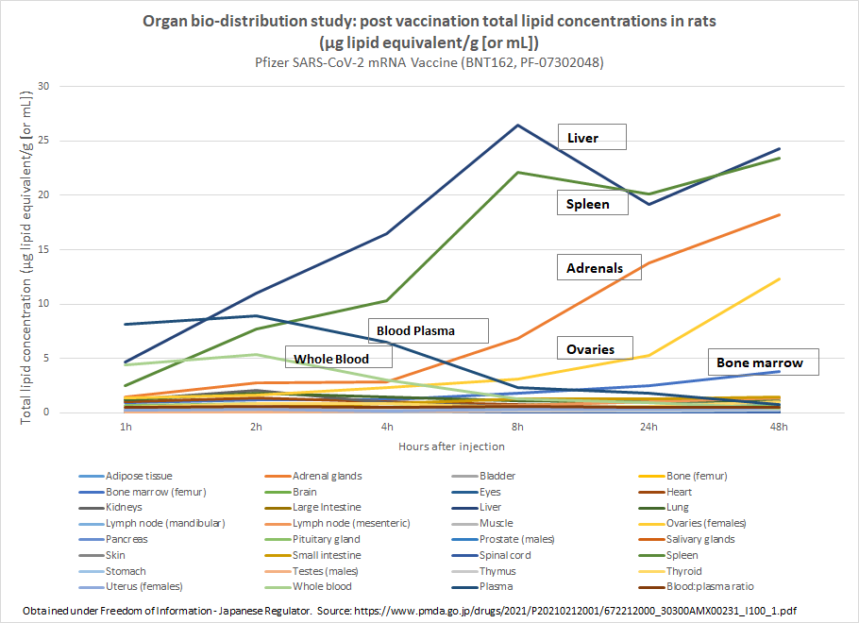
Finally I’m not seeking to prove that I’m right. I’m sure other minor errors will arise. I’m trying to bring to the public’s attention legitimate points about the safety and risk/benefits of these vaccines. I probably screwed up on some of the details. If I had gotten everything perfectly right, the material would have taken months to publish. I thought it was more important to get out an “imperfect” report than a perfect one. If YouTube were to find one little detail objectionable, they would censor the content. I think that’s a really bad thing. YouTube is wrong for banning ivermectin videos even after the systematic review was published that concluded ivermectin works. They should immediately remove any videos saying ivermectin doesn’t work and compensate content providers for their lost revenue.
I get thousands of emails a day and hundreds of DMs so I can’t personally respond to all comments.
Hopefully, you can see the forest through the trees here. Yes, you can nitpick my document to death, but there is no way you can attack the main points which are that the current gene-based vaccines are extremely dangerous and are killing healthy Americans in extremely large numbers. We are well beyond traditional stopping conditions. The cost-benefit analysis no longer favors the vaccine… in fact for the delta variant, UK government stats show that vaccination doubles your chance of death. The vaccines should be halted. Kids and the already infected should not be vaccinated regardless. If you disagree with any of those points and have proof, please DM me.
And finally, I’m not the one hiding in the shadows. Members of Congress don’t answer when I ask questions like “So how many Americans have to die before you will call for a halt to the vaccine?” or “Don’t you think we should have the safety data in hand before we recommend to pregnant women?” or “Where is the cost benefit analysis of the vaccine for each age group?” or “Why aren’t you asking the NIH for Fauci’s unredacted emails?” or “How many people have been killed so far by the vaccine and where is the proof of no deaths?”

I know this stuff is hard to hear. I know there is cognitive dissonance. Attacking me is a way to deal with the cognitive dissonance. But I’m not the enemy here.

How do critics explain the peak in the CMS data when the vaccines rolled out?
If the vaccines are perfectly safe, there should be no “hump” in the death rates in the CMS data (Medicare). So, how do you explain the huge hump in deaths coinciding with the vaccine rollout?

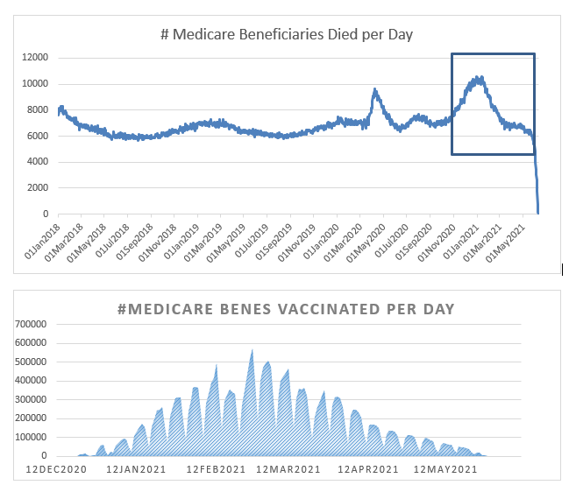

When was the last time you heard of a 16 year old girl who cannot talk or read 48 hours after getting vaccinated?
From: Kyle xxxx
Sent: Saturday, May 29, 2021 1:02 AM
To: Byram Bridle
Subject: Information request - please
Hi Dr. Bridle,
I heard your interview today.
My 16 year old healthy sister-in-law was in ER today. (Alberta)
She couldn’t talk or read this morning.
Docs don’t connect dots but I told mother-in-law to demand testing. They found markers to indicate clotting in blood. Further CT testing didn’t reveal any they could see. Her neurological issues improved enough but she feels spacey. They sent her home blaming stress and perhaps her birth control. She had the Thing 48 hrs ago. Pfizer.
Any recommendations of or info you can send is helpful. She’s not on any blood thinners but was on Accutane (does it thin blood? I know it has nasty side affects as well).
Best regards,
Kyle

If the vaccines are so safe, why are they so overwhelmed with reports?
From: COVID19aefi <AEFI@toronto.ca>
Sent: June 17, 2021 11:15 AM
To: 'ira.....@xxx.net'
Subject: RE: Adverse event report
Hi Ira,
Thank you for your email to AEFI team at Toronto Public Health. I can confirm your report has been received and is in queue for follow-up. We are managing an abundance of reports at this time, so it may take two to three weeks before you receive contact from an investigator.
If you have any questions or concerns, please call Toronto Health Connections at (416) 338-7600.

If the vaccines are so safe, then why were over 500 records removed from VAERS since vaccines were started and 30% of them were death records?
Also, the records have horrible quality control. They are supposed to be reviewed by HHS to correct them before being entered into the database so they are consistent, e.g., if there is an autopsy, the record should be coded as a death and isn’t.

If the vaccines are so safe, then why are people afraid to look at the facts?
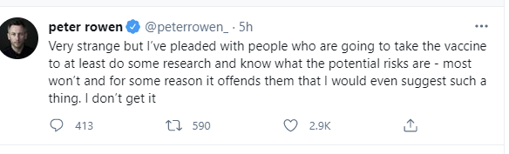
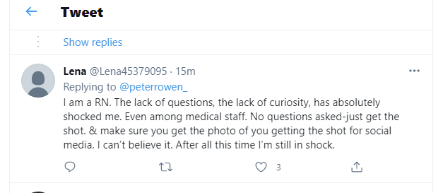
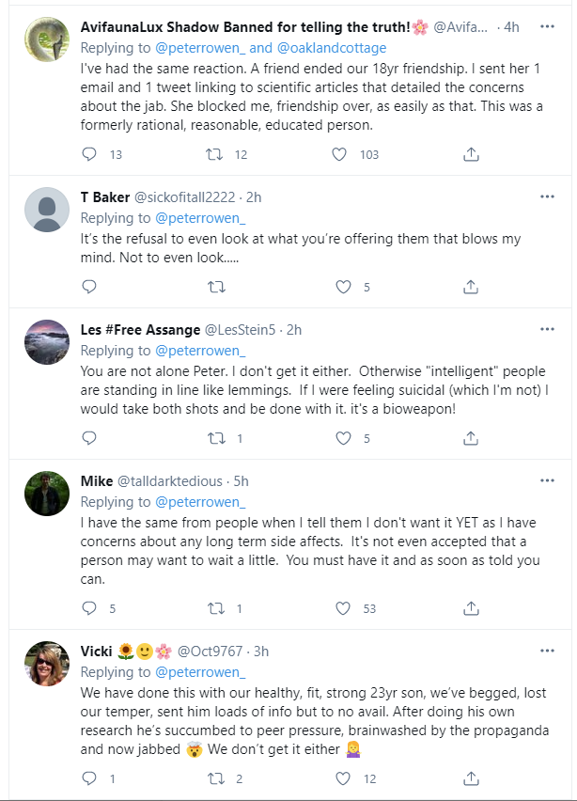

If the vaccines are so safe, how can incidents like these happen?

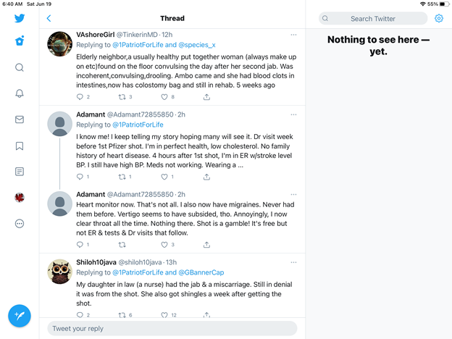
“The above is a screen shot from an unbelievable Twitter thread posted yesterday asking if people had witnessed vaccine adverse effects. I thought you might be interested in this account of HTN beginning 4 hours after dose. There are so many sad entries…”

If the vaccines are so safe, why are so many injured people afraid to speak out?
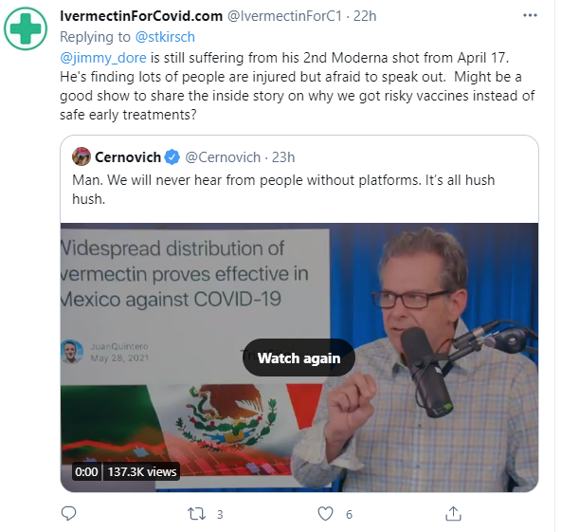

When was the last time you heard four healthy pilots dying in one week? Never, right?

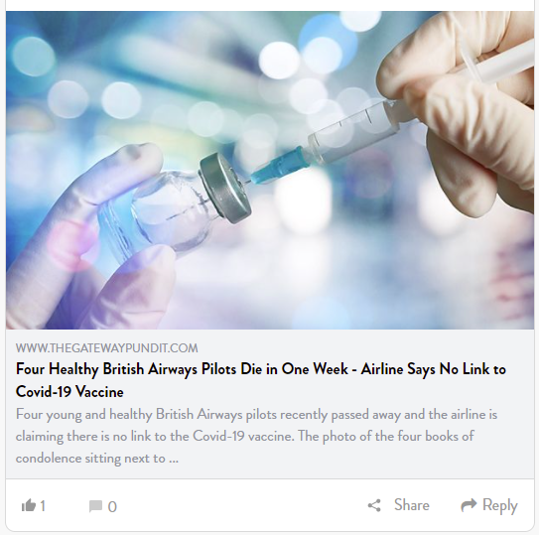

If vaccines are safe and effective, how do you explain this?
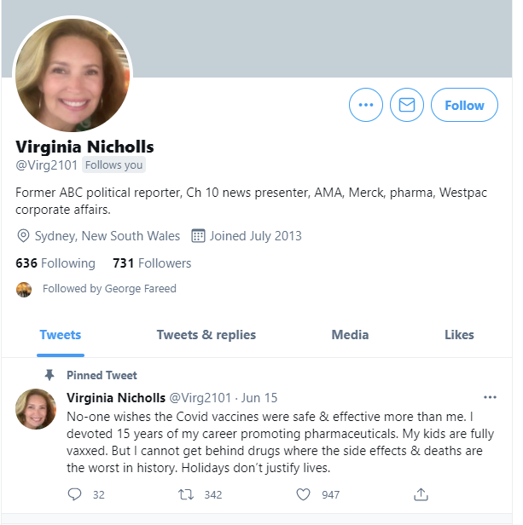

If the vaccines are so safe, how do you explain a 3% rate of long-term severe symptoms for the people in my area?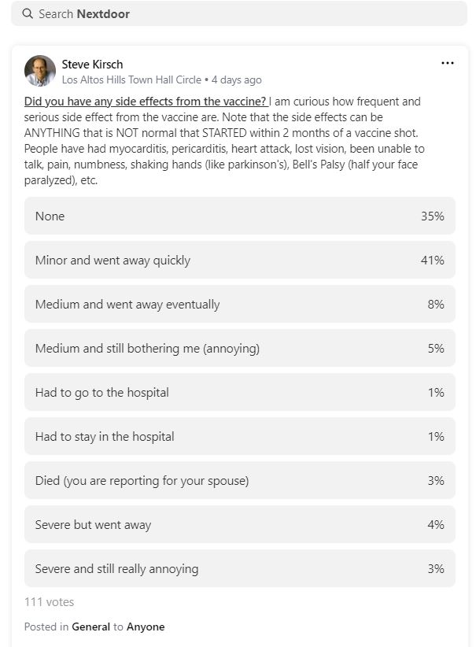

If the FDA is doing its job and isn’t corrupted by money, how does this happen?
For fluvoxamine, they had two trials, both 100% effective, and they said there wasn’t enough evidence for an EUA which is the LOWEST standard of evidence. There was not a single ounce of neutral or negative evidence.

Biogen’s Aducanumab for alzheimer’s had no benefit and got FDA approval which requires a much higher standard than EUA. This is absurd. There is no explanation for this other than corruption.

Or how about NIH funding for the fluvoxamine Phase 3 clinical trial. The trial ended a month ago and they still haven’t figured out whether to fund it (it will be another few months). Yet for the Merck antiviral, billions of dollars. How do you justify that? Fluvoxamine is bird in hand.

Congress is totally asleep to allow this to happen without asking any questions. This is why Novavax can’t get approved in the US: it is a rigged system.

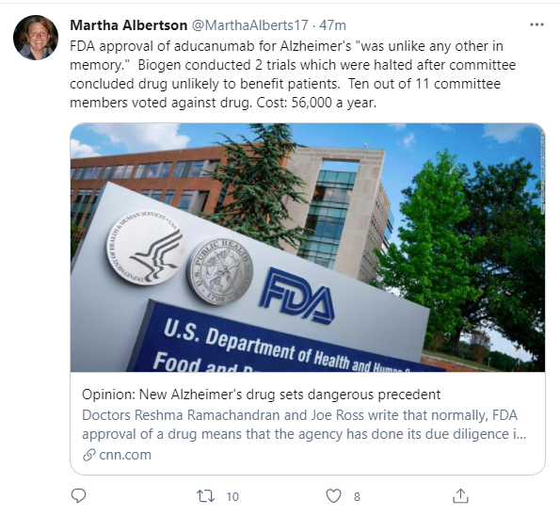Furthermore, the FDA took NAC off the shelves even though it kills nobody, and makes the vaccine available without a prescription despite the fact that it has killed over 25,000 people. They did that because NAC can be used to treat COVID and if there is a COVID treatment, the vaccines can’t get approved.

Finally, the Biden Administration is investing $3B for antiviral development. Most all of that will go to Merck. But there is a spectacular antiviral called GS-441524 which is very safe and effective. No money for that. Or Interferon Lambda…. No money for that. Or proxalutamide… no money for that. And existing repurposed drugs like ivermectin and fluvoxamine? No money for that. How are these decisions being made? Note that in the real world, most patients present very late, when antivirals are a lot less useful. More money down the drain. And the pill they are investing in reportedly has teratogenic effects.

How can you look the other way?
Telegram Group with over 100,000 members and an unknown number of vaccine obituaries

There are thousands and thousands of obits like this one:
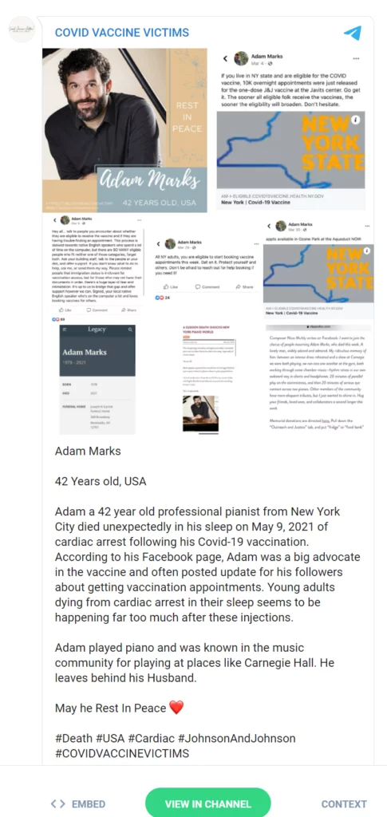

The Fact Checkers will not debate the facts
I have received messages like this one:

My friend sent me this Reuters article back in response: https://www.reuters.com/article/factcheck-vaers-symptoms-idUSL2N2NZ1KB. Learning that ordinary individuals can post results to VAERS has shaken my faith in the death and adverse effect numbers you guys were citing. I'm not as skeptical of anecdotal evidence as my friend is, but what would you say in response to that? Are deaths and reports verified before they're posted into VAERS?

This is cherry picking facts. The facts are that HHS doesn’t just publish anything that is submitted without any review. They review each one before assigning an ID and posting them. If you post a false VAERS report it is a federal crime that can put you behind bars. To date, none of these fact checkers have identified any “joke” entries. If the database was bogus, why not show that all the death reports are phoney?

And you cannot fake the death data unless you kill youself. The CDC numbers show 25,000 excess deaths. How do the so-called fact checkers explain that? They don’t.

This is why when you challenge them to defend their “fact checks” they ignore you.

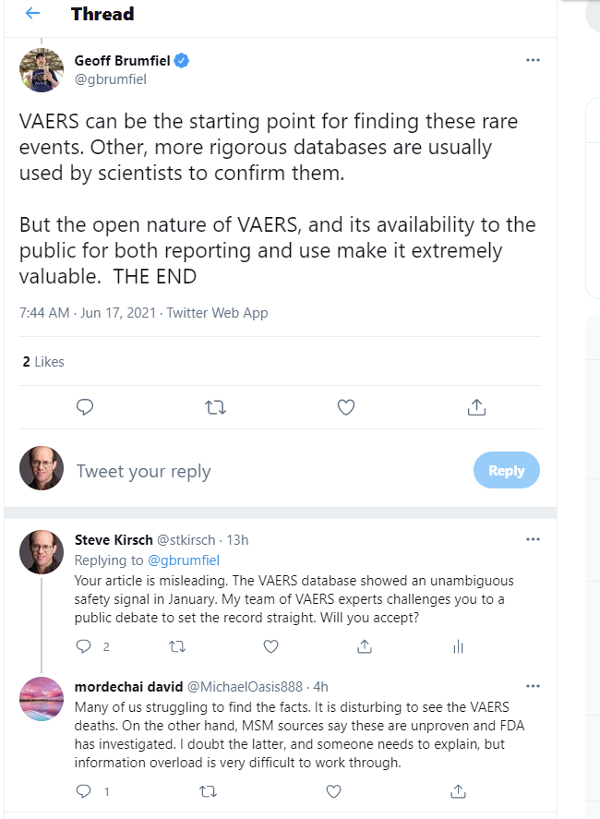
When you reach out to the NPR fact checker, he ignores you. NPR is promoting the false narrative as well and they refuse an open debate because it would tarnish the reputation of NPR that their fact checkers are spreading misinformation.

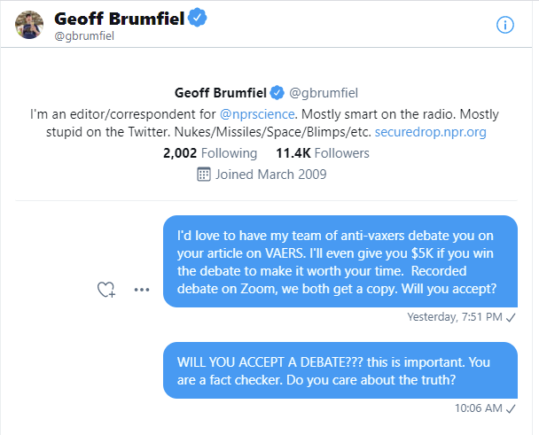

What is really happening: under reporting of events
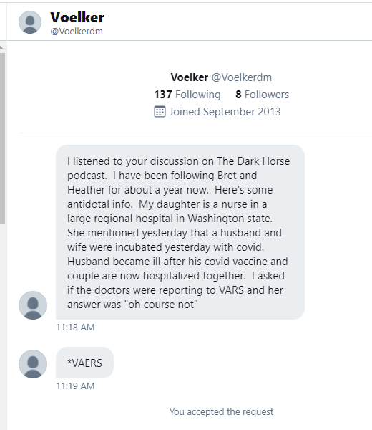

The underpinning of science is to have open debate
So why won’t anyone prominent debate us? This is what science is all about.

Check out this tweet from Joy Reo and watch the video.

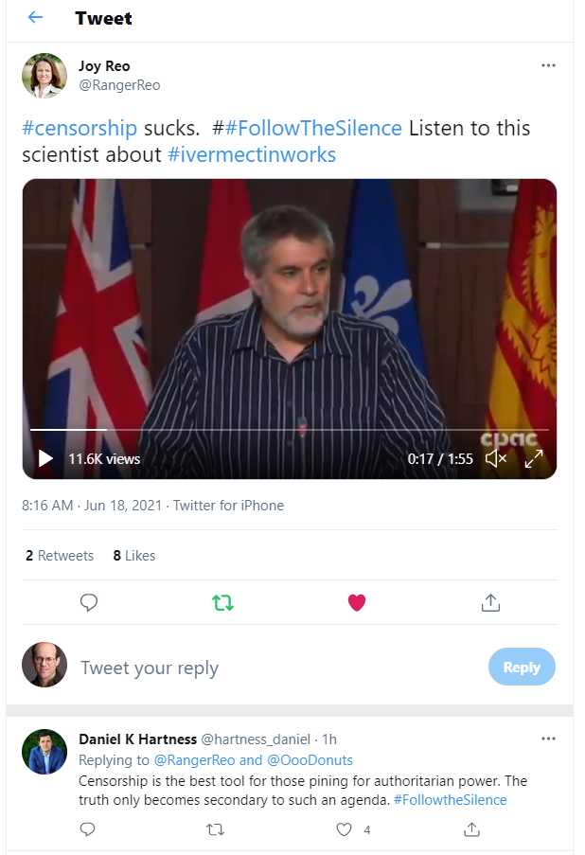

Independent scientists, like Annie’s mom, are horrified

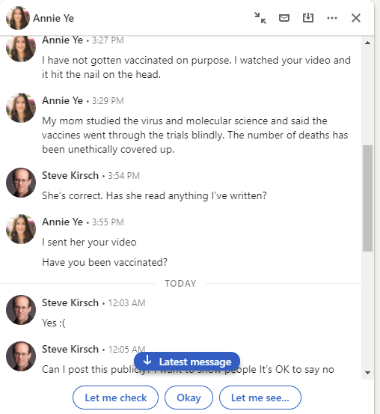

People who were skeptical are becoming less skeptical
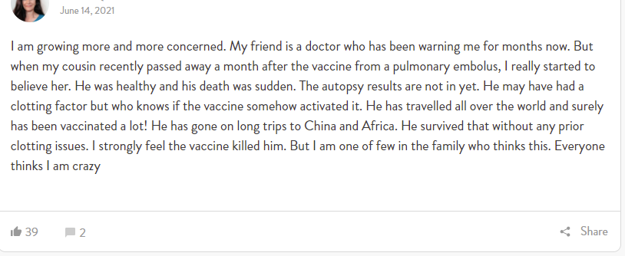

Thirteen year olds die all the time, right? This one just “happened” to die 3 days AFTER the vaccine.
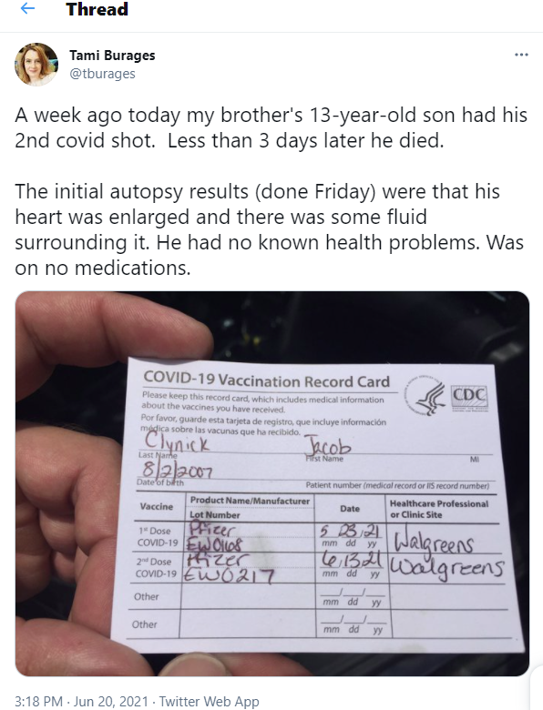

CDC “math”: the benefits outweigh the risks… NOT
On June 23, the CDC said the 1,226 cases of heart disease in children are nothing to be alarmed about. The vaccine is safe.

They point out the benefits for boys aged 12-17 (per million per year):
- Prevent 5,700 COVID cases
- 215 hospitalizations
- 71 ICU admissions
- 2 deaths
With the risk being:
- 56-69 cases of heart disease

In short, the CDC believes it is preferable to give 70 previously healthy kids heart problems to save 2 lives. That’s based on all their own numbers.

However, the head of the CDC gives different numbers in her own tweet:
To put this into perspective, if we vaccinate 1 million 12-17 year olds, we could see 30-40 MILD cases of myocarditis. In this same 1 million, through vaccination we AVOID: 8,000 cases of COVID-19, 200 hospitalizations, 50 ICU stays & 1 death. The benefits far outweigh the risks.

In short, we don’t know whether to believe the CDC or the head of the CDC. The numbers are different.

The numbers above assume the vaccines are perfectly safe. We know they kill 1 in 5,000. Since there are around 20M kids 12-17, that means killing around 4,000 kids in order to save the lives of 20 kids. Makes perfect sense, doesn’t it? Of course not. It’s nuts.

Even if we are really generous and say these vaccines only kill 1 kid in 250,000 which is a 50X lower death rate than average. This would mean 4 deaths per million to save 2 lives per year. So breakeven happens after 2 years (or 4 years if you believe the head of the CDC).

So even in our most optimistic scenario (a 50X lower death rate and zero chance of being disabled), vaccination is silly in the short term.

And of course the death rate is nowhere near 1 in 250,000. There are 1,226 cases, and at least one death we know about: 13-Year-Old Michigan Boy Dies 3 Days After Second Dose of Pfizer Vaccine, Aunt Says ‘Moral, Ethical, Health’ Questions Need Answers. But the press doesn’t bring that up. The death of previously healthy kids simply do not factor into the cost-benefit calculation because the CDC says nobody dies from myocarditis. Sure. Right. Tell that to Tami Burages. But that article is censored on social media so nobody will find it. As the article says, “The Defender is experiencing censorship on many social channels. Be sure to stay in touch with the news that matters by subscribing to our top news of the day. It's free.” So social media is censoring Children’s Health Defense. Seriously? We are censoring content from organizations that are trying to save our kids from dying. I do not understand where these social media companies can source so many censors who lack any compassion or a heart. And why are the employees of these companies remaining silent as this censorship happens. Is it right that this story should be censored?? Apparently yes, since nobody in Congress is saying a word of objection. So kids die and nobody knows. I think this is really tragic. It makes me ashamed to be an American.

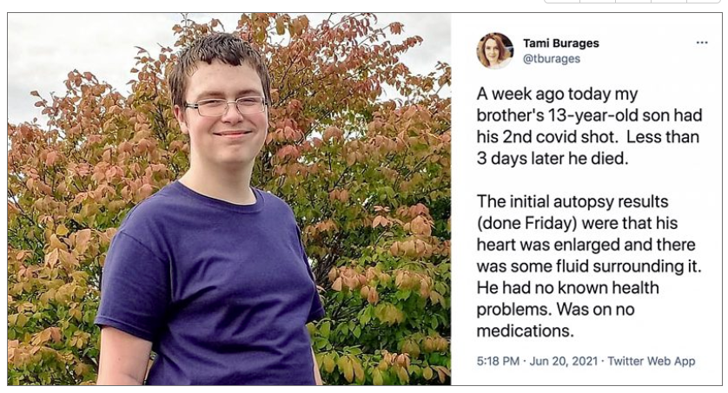

The results are even more skewed if we add the unethically suppressed early treatment protocols to those who get COVID. Then even if the vaccines were perfectly safe, it would still be silly.

You are looking at an absolute risk reduction of death of less than 0.0002%. Seriously?! We are vaccinating every kid, likely killing 1 in 10,000 or more, giving 1 in 100,000 a permanent disability for a 0.0002% risk reduction?!?! What are parents thinking?!?!?

But the bigger deal as I’ve said before is that we have no clue what the reproductive toxicology numbers are. We are vaxing first, collecting data later. It used to be the reverse. We are now throwing caution to the wind and doing everything the reverse way… vaccinate first, do safety later. I’m just amazed that no mainstream doctor is speaking out about this. That’s the real crime here. The medical community is totally asleep at the wheel here, urging parents to vaccinate their kids. Why isn’t any med school Dean speaking out about this? Are they all brain dead?? See my comments above on this (search for 82%).

And let’s not forget that kids are naturally immune to COVID so vaccination is pretty silly. It would be like doubly vaccinating someone.

Thank you YouTube for removing my videos
Not just the ones I post that are vaccine related, but if I’m on someone else’s show like Bret Weinstein or Dr. Drew, those videos get removed and the channel gets another strike so they can’t upload videos anymore. Sweet. I can no longer appear in any YouTube video on anyone’s channel. If I appear, that video will be removed.

And the CEO of YouTube will not talk to me. The head of health and safety, Garth Graham, ignores all my emails. So there is no appeal.

Thank you Twitter for disabling my account so that I cannot get the word out
I would like to thank the censors at Twitter for disabling my Twitter account so that I can’t communicate with people to get the truth out.

I never said in my tweet that 25,800 people had died. I simply made a speculation, based on CDC death data (and 5 other ways to derive the same number), that up to 25,800 people MAY have died from the vaccines. That’s a true statement. Truth is not a defense though. Twitter has no problem with censoring the truth. Opinions (in my case, speculation based on government data), are not ok either.

I wonder: Are there any employees at Twitter at all who think it is wrong to revoke accounts for making true statements based on government data?? That true statements and questioning our government officials should lead to suspension of your twitter account? Is this the new America? So much for the first amendment.

We need to learn the lesson that when people die at the hands of the US government, including kids (as Children’s Health Defense learned), keep your mouth shut about it. Otherwise, your Twitter account will be removed. That’s the message big tech is sending to America. Makes you really proud to be an American, doesn’t it?

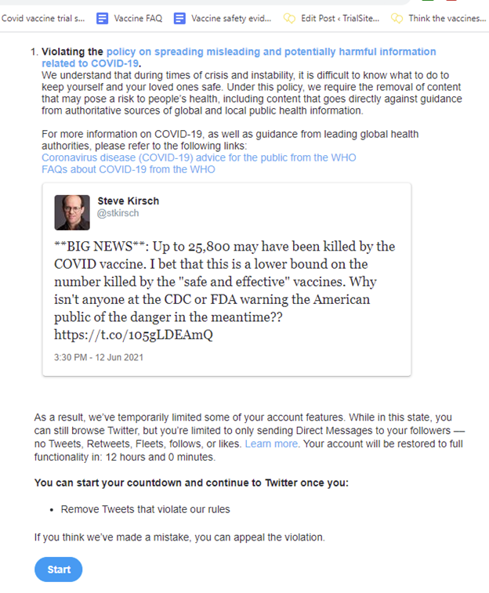

FAQ / Q&A
How did you get started on this?
On May 16, 2021 my carpet cleaner Tim Damroth told me that both he and his wife were disabled due to the vaccines. Today, June 24, Tim is in excruciating pain and has lost tens of thousands of dollars in medical costs and lost income. How can a husband and wife both be suffering severe effects of a perfectly safe vaccine? The odds of that happening is about 1 in 1 trillion. When I checked the death rates of Ira Bernstein who has 600 vaccinated patients and 1 death, it was clear to me that we were being misled, so I started collecting data and I wrote it up in this article Think the vaccines are safe? which was published on TrialSiteNews on May 25, 2021. It is 223 pages long when printed and I highly recommend it if you want the full 360° view of all the players. It has over 15,000 likes on Facebook and has been viewed over 500,000 times.

This document is the more “up to date” version of my original article and is updated daily. It is focused on the vaccine. It is only 71 pages and on a typical day there are around 50 people reading it online at any point in time.

I don’t know anyone who died and I know thousands of people. I don’t believe your numbers.
I personally don’t know anyone who has died from COVID or the vaccine either! But it doesn’t change anything I’ve written. If any of my data is incorrect, let me know. The 30,000 number is derived five independent ways. Since 1 in 5,000 die, it’s perfectly normal for most people not to know anyone who has died. I know one doc with 3,000 patients with no deaths and another doc with 600 patients and 1 patient death and 1 staff death from the vaccine.

Why do a lot of people dismiss your document?
Because they don’t have the time to read it and even if they do have the time, they don’t feel they have the expertise to evaluate it. Since the opposition won’t debate me, people can’t see both sides of the argument at the same time. So they side with the status quo by default.

Other people work for a Member of Congress who has taken a pro-Vax stand. Thus, reading this document is a complete waste of time for them; they aren’t going to change their Member’s opinion which is driven by party politics. So they don’t read this doc and they don’t want to engage in any discussions about it.

On the other hand, nearly all my smart engineering friends find this document compelling however, even without medical expertise. It’s math and statistics. There are one or two exceptions, but in general, engineers figure this stuff out pretty quickly.

Why isn’t the mainstream press reporting on this?
Cognitive dissonance. They find the whole premise of a false narrative to be so unlikely that they can’t bring themselves to read this document. Instead, they dismiss it without reading it. Also, it would destroy the credibility of the newspaper for spreading the false narrative.

As of June 25, 2021, only one newspaper reporter has read this and reached out to talk to me and all the main scientists mentioned here. He’s now 100% convinced I’m right. But his newspaper is very conservative so he has to tell the story in little pieces. If you are a reporter and would like to verify this, I will be happy to put you in touch with him. Nobody has taken me up on my offer. Imagine that.

Why isn’t the CDC looking at the data?
I know people who work at the CDC. They are focused on getting more people to take the vaccine. They don’t have time to look at the safety data. They don’t have the staff either. There were no recruitment ads for people to look at the 6,000 deaths. And since the CDC thinks the spike protein is harmless (ignoring the peer-reviewed data that makes it clear it isn’t), they can never associate any of the deaths to the vaccine since there is no plausible mechanism of action. So all these deaths are simply “bad luck.” Got that?

Why isn’t the FDA looking at the data?
This would take a “research project” and they are too busy doing other things. Sound too hard to believe? I have unassailable proof that I will show to any reporter of major media who will write the story. Nobody will respond to our outreach from our PR agency (G.F. Bunting & Co).

Why aren’t Fauci’s unredacted emails showing there is a cover up being requested by a Democratic committee chairman/chairwoman? This would show Fauci to be duplicitous.
Nobody in Congress will answer that question and the mainstream media will never ask that question.The NIH has said it will comply with a letter from any Committee Chair, but no Democrat will request the emails since it will reveal they were asleep at the wheel. It’s the same reason the FDA, CDC, and NIH are looking the other way on the death data and why the mainstream media refuses to expose the false narrative: because it makes everyone look bad. So they are all circling the wagons with a code of silence. Academia won’t speak out since they will lose their NIH funding for decades. Nobody will debate me or anyone else who wrote documents listed in this document. They are all afraid of the truth. And thanks to Twitter, YouTube, Facebook, Medium for censoring me so that nobody will find out the truth. CNN will never have me as a guest.

How come the press isn’t asking the CDC how many people have died?
They are too busy promoting the safe and effective vaccine to people. And the CDC will just say “nobody” and the press will lap it up and report it without questioning whether they are telling the truth. They will never consult with an expert who actually understands what is in this document.

Why did YouTube remove the 3.5 Bret Weinstein’s darkhorse podcast featuring the inventor of the mRNA vaccine with 800,000 views and rave reviews?
Because they do not want anyone to learn the truth. You can watch it on Odysee. I know a bunch of people have written to me that it was so good, they watched it 3 times!! By keeping people ignorant, the masses will follow government instructions without asking any questions. I was fooled into thinking the vaccines were safe and effective so I was vaccinated. But I now realize it was a huge mistake. I wish I had watched that video so that I would be fully informed of the completely unnecessary risks of being vaccinated (and the miniscule benefit of like 0.2% absolute risk reduction). But I wasn’t given that option and YouTube is doing their part making sure people will remain in the dark about how deadly these vaccines are. Here is the original link to the YouTube video that was removed.

What is the stopping condition for the current COVID vaccines?
There isn’t one. It is undefined. We’ve never done anything like this in history. They will not stop the vaccine no matter how many healthy people are killed or disabled. They are putting their foot on the gas.

What does the Biden administration say about this?
They completely ignore the facts. Instead, here’s what they do:
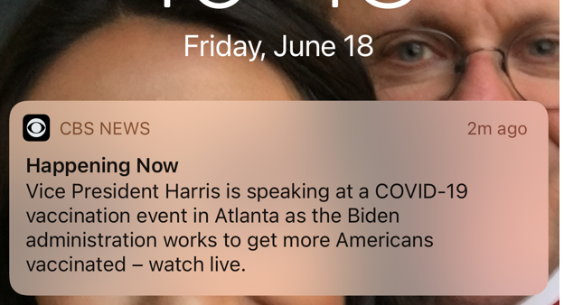

What do the fact checkers say about this?
They will cherry pick data and studies to try to create uncertainty. None will debate us. None are as qualified as our experts to debate so they will lose badly if we could have an open discussion. See section above.

How long does it take to get a VAERS report published?
Dr. McCullough submitted 5 VAERS reports in April. As of June 20, none have been vetted and given permanent VAERS numbers. There are now over 300K safety events with permanent VAERS numbers assigned.That alone should be cause for alarm but none of these events have made any difference at all.
.
Why are kids getting myocarditis from the vaccines?
I strongly suspect this is a case of confounding masking events in other cohorts, and that the effects are not limited to the adolescents.
In other words, there are so few naturally occuring cardiac events happening in adolescents, that this effect of vaccination is easily detected.
In older cohorts, the natural incidence of cardiac events will make it hard to detect the vaccine-related events.
How significant is the false narrative?
When it finally comes crumbling down, it will forever damage the credibility of the following entities all of whom are clinging to the false narrative:
- FDA (looks the other way at the safety signals including proof of fraud in the clinical trials; refused to release any internal studies that show the vaccines are “safe” since they would be immediately discredited; totally corrupt organization for approving a harmful Alzheimer’s drug, saying insufficient evidence on FLV EUA, and for taking NAC off the market after 60 years. How obvious does this need to be before Congress takes action?
- NIH (unethically suppresses early treatments even after systematic review published)
- CDC (focus is all on vaccine hesitancy; no focus on safety unless massive complaints like myocarditis; they still think the spike protein is harmless and that nobody has died. This is indefensible. 20 year olds die in their sleep <24 hours after vaccination and that is not a death caused by the vaccine? Are you kidding me? They are living in a fantasyland. They will not make V-SAFE data publicly available; release only tiny snippets of pieces they want to release).
- Congress (will not hold Fauci responsible for creating COVID and the cover up, will not request his unredacted emails, will not stop the vaccine rollout; asleep at the wheel for not seeing the obvious corruption at the FDA. Is Rand Paul the only guy who asks any questions? Anna Eshoo staff will not answer simple questions like stopping condition on the vaccine or why she is not requesting Fauci’s unredacted emails from the NIH.
- Mainstream media (refuses to read this document except for 1 reporter who spoke to all the main sources and verified it 100%; fact checkers refuse to answer a legit challenge)
- Medical academia (will not debate this document; cannot find fault)
- Social networks (censorship. Whatever the WHO says is “right”)
- The President (who has a 70% vaccination goal no matter how many healthy people must be killed to get there)

BA pilots
Captain Nicholas Synnott aka Nick Synnott died June 11, 2021. He had been hospitalized from COVID but was released 6 months ago.

An inquest in Salisbury was told airline pilot SFO Edward Patrick Brice-Bennett, 33, from Ramsbury, was found on one of the trails by the side of his bike by a member of the public collapsed and unconscious at the is a mountain bike trail park, Tidworth Freeride Bike Park, on June 2, at 12.17pm. He was certified deceased later by paramedics at 13.02pm. A post mortem examination showed two conditions, abdominal trauma and haemoperitoneum, but no cause of death had yet been ascertained, Toxicology and histology tests have been ordered, and the inquest adjourned to a date to be fixed. Details

SFO Grant Mercer, keen ice hockey player, dirt bike competitor seemingly very fit and active. Died May 4, 2021 by suicide.

Captain Richard Green had a heart attack during a run. Don’t have a death date.

Our debate offer
Our team of 7 experts (including Dr. Robert Malone and Dr. Byram Bridle) will debate any group of seven (or fewer) recognized relevant authorities (e.g., a representative from any of CDC, FDA, NIH, member of Congress, medical expert who regularly appears on CNN or any other major news media, any scientist who is a recognized authority on vaccines, infectious disease, public health, or epidemiology), or any mainstream media journalist with a scientific background.

This makes it: 1) worth our time, and 2) enables us to discredit multiple spreaders of the false narrative in one debate.

Sadly, no one wants the truth exposed. They are all hiding in the shadows. TrialSiteNews extended an offer to Cliff Lane at NIH (who immediately refused) and the WHO (who refused to answer). It’s pretty sad.

Science is all about open debate on important issues and nobody supporting the false narrative will show up at the debate table to defend their position that these vaccines are safe.

Permission
It’s important this information gets disseminated. You have my permission to re-use this information freely. Feel free to translate, make excepts, share, etc.

Take action
If you are as infuriated about this as I am, please sign up for the Vaccine Victims group at Locals.com. This group is free to join and is for anyone who supports stopping the current vaccines and exposing the truth.

If you know anyone who works at YouTube or any other social network, please point them at this page.

Please follow me on Twitter and Clubhouse: stkirsch

Please let your friends and family know about this document by posting on social media. Right now, on Jun 18, there are over 30 people reading this document. Let’s drive that number through the roof.

Feel free to translate this document or any subset into your native language. Let me know and I’ll post the links here.

The WHO recommendation for kids not to get vaccinated
On June 22, 2021, here’s what the page said “Children should not be vaccinated for the moment.” Emphasis mine. You can see it below. Of course, they changed it for political reasons so they could keep their funding. But there was NO explanation for the reversal.
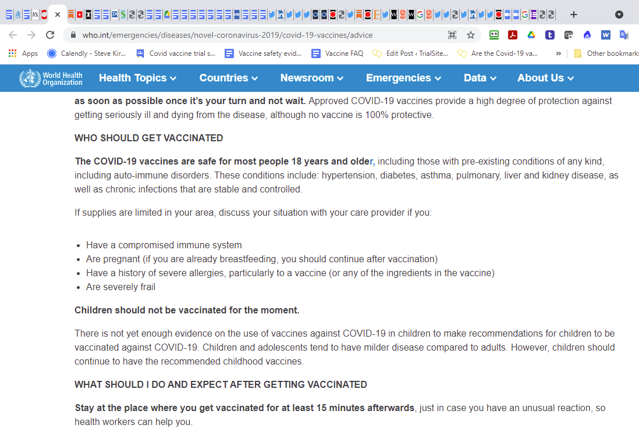

Justification for 2X higher death rate for vaccinated people in UK against Delta variant
COVID-19 Delta variant death rate is 2.2x higher for the vaccinated population of England
Statistically significant (Vax=37/17605, Unvax= 34/35473, RR=2.19, p<0.01)
—————————————————————-
England, 1 February 2021 to 14 June 202
Unvaccinated: 35,521
Deaths: 34
————————————
Vaccinated: 17,642
Deaths: 37
Page 12:
https://assets.publishing.service.gov.uk/government/uploads/system/uploads/attachment_data/file/994839/Variants_of_Concern_VOC_Technical_Briefing_16.pdf
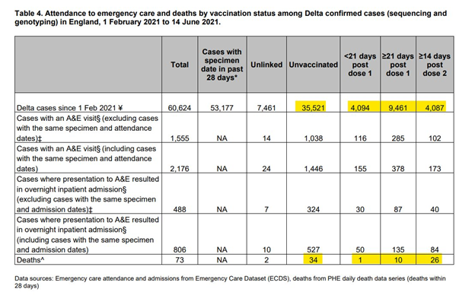
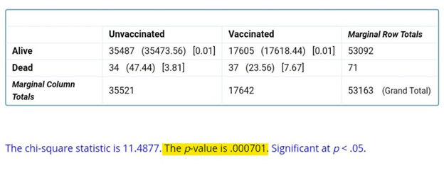
So if you get Delta, it’s bad news if you are vaccinated. But are vaccinated people less likely to get Delta? Yes, they are. Approximately 62% of the UK is vaccinated so that means that we would have expected 57291 people to get Delta, but only 17642 did suggesting a 3.2X lower rate. 3.2/2.2=1.45 which means you are still 45% better overall if you are vaccinated, but that assumes no deaths and disability from the vaccine.

The UK population is 66M. .38 of that is 25M unvaccinated with 34 deaths. So your chance of dying (without early treatment) without a vaccination is 1.36 deaths per million. Vaccines reduce this by 45%, so you’re looking at an absolute risk reduction of .6 deaths per million.

So if we vaccinate the entire UK, we will save a net .6 * 66 lives, i.e., 40 people’s lives will be saved over a 6 month period.

However, the vaccine itself will kill at least 1 in 10,000 (using a more conservative than our 1 in 5,000 US number). So, 6,600 people in the UK will die (and a lot more will be disabled).

So it’s simple… the vaccine will save 40 people’s lives every 6 months, but 6,600 people will sacrifice their lives to save 80 people a year.

Which makes you wonder: Is anyone doing the math???

And finally, with one of the top vaccination rates in the world, the UK is doing great (OK, just kidding) on this graph of COVID cases and deaths per 100,000 people.

So you can clearly see the benefits of vaccination, right? Higher cases and deaths and that’s not even counting the deaths from the vaccine itself:

Appendix
Notes I’ve received, all self explanatory.
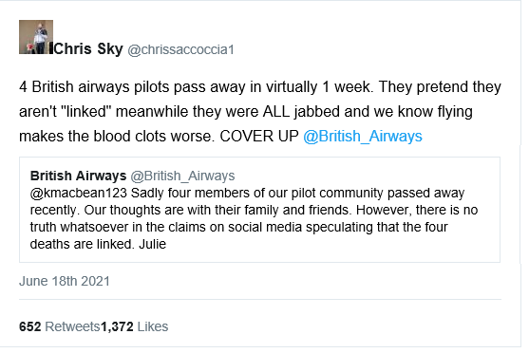

My name is Doctor xxxxx. I'm an Internist in Chicago Illinois. Below is a description of one of my patients who did have both Pfizer shots and then began to develop horrible left sided lower abdominal pain for which he had to be hospitalized.
She is a 62 -year-old female who had a 'shot' 2.5 months ago and she now has a 6 cm ovarian cyst that might be taken out soon. She had to go to a hospital for the evaluation. I'm not sure how we would do a spike protein assay if she wanted to consider this..
Patient received these shots on 4/6 and 4/23 of 2021. She arrived in the ER for this left sided pain on June 10, 2021.
She also had a pancreatic cyst that grew from 2 cm to 7 cm after her getting the shot. She was being followed and the cyst in the pancreas never really changed much until right after she received a shot. A biopsy has been performed already for this cyst of the pancreas on June 7, 2021, which was shown to be negative for neoplasm.
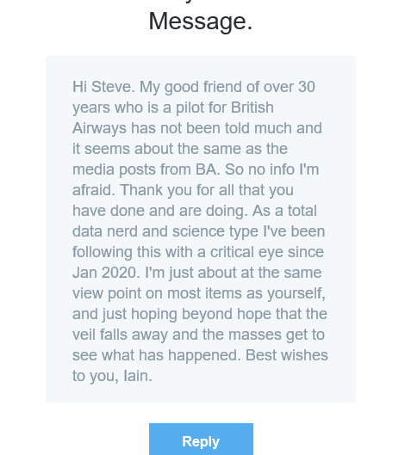
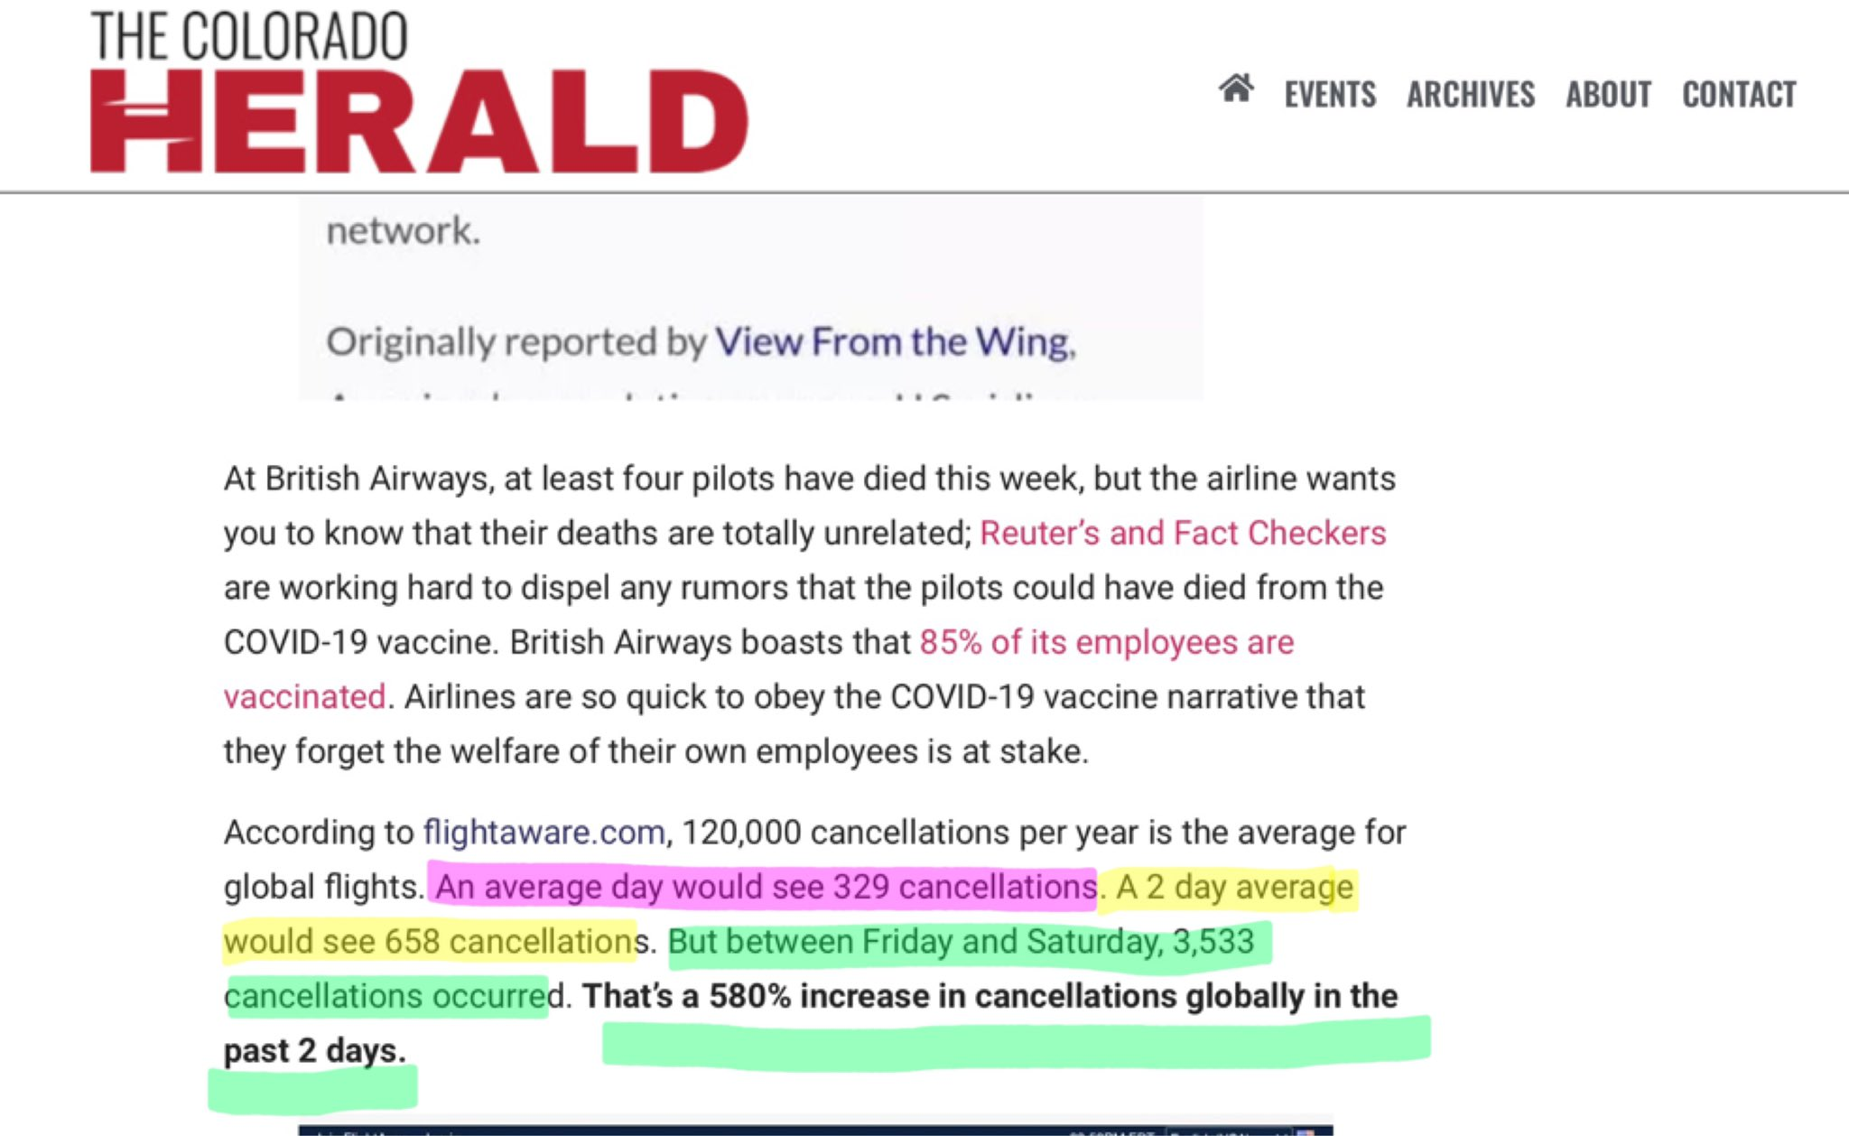

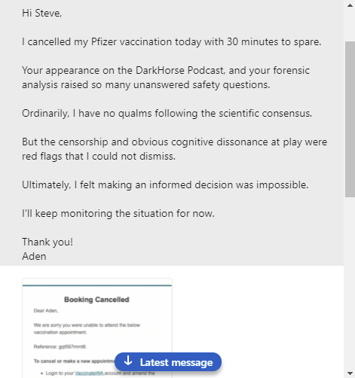

We (the Canadian Covid Care Alliance) received the following message from an optometrist on Friday. It is perfectly safe and effective as long as you ignore the injuries and deaths. What is equally troubling is when I tell other MD colleagues that I know a 24 year old athlete who died in his sleep less than 24 hours after Pfizer jab, and the docs just sort of shrug and think “oh well, no big deal”.
Message:: Practising optometrist in Ontario.
Seeing Post c19 vaccinated cases trickling in suffering fr branch retinal vein occlusions (eye stroke), post lasik corneal inflammations, conjunctival hemorrhages, blepharitis & inflammatory dry eyes etc.
Find it extremely laborious & difficult to report vaccine injuries in my profession! Even more frustrating to witness staff and patients not making true informed consent re taking novel vaccine/gene therapy into their bodies when the motivations for doing such are family/friends’ pressure, mainstream/social media’s glowing reporting of covid vaccines AND no other safer alternatives, future implementation of vaccine passports for travel/ group events etc.
--------------------
I am aware of the FOIA request from Canada that resulted in the disclosure of the Japanese document, which is in my opinion very shocking.
I am already alarmed by the high concentrations found in the spleen. I think this is highly significant for the potential to cause neurodegeneration due to prion protein misfolding in coming years. There is already a very clear understanding of the large role that germinal centers in the spleen play in eventually inducing Parkinson's disease.
However, the fact that high concentrations were found in the ovaries and the adrenal glands in this Pfizer study is perhaps even more alarming. The ovary accumulation could account for the high number of miscarriages in pregnant women who were vaccinated, and also in the irregular menstrual cycle, in some cases associated with heavy bleeding and discharge of debris. It may also cause future infertility problems in young vaccinated girls and women.
I suspect it may show up in all the glands, since they have greater access to the lymph system, and it is very clear that dendritic cells carry the mRNA into the lymph system from the injection site in the arm.
I can't predict what effects the mRNA and the production of spike protein would have on the adrenal glands, but I can't imagine that it would be good!
I also wonder about the thyroid, the pituitary gland, the pineal gland, the prostate gland and all the rest. Were they even tested?
Stephanie Seneff
Senior Research Scientist
MIT
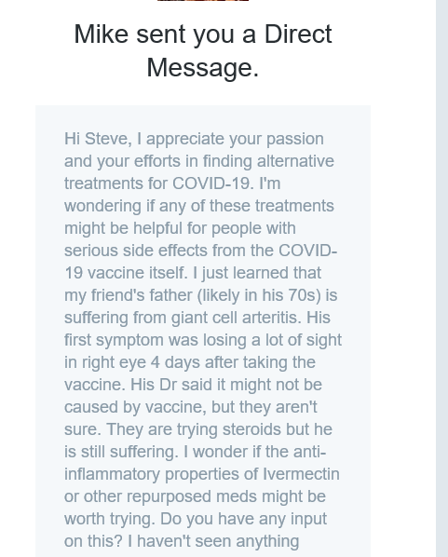

I have to tell you that my father got the jab and he has been hospitalized with idiopathic hypertension about 15 times since he took the jab. The ER doctor told me she has had many people come in saying “ I did not feel or have this before COVID jab...”

I also work at a school and kids have been complaining of headaches constantly for having a mask all day and during recess some of them have collapsed. The worse part is that when I ask them to take a mask break they are petrified of doing so!
What is happening ??
Thank you,
-------------------------------------
The contact information I have is for K… S… , who is a nurse practitioner, and was the young woman in the middle of the other two on xxxxxxxx. Still has multiple tremors and severe pain that has continued for 6 months after being vaccinated and haven’t stopped.

She is intelligent and articulate and is being suppressed. Her medical background gives her good insight into what is really going on. She will tell you about her journey to find treatment, the harassment from others who do not believe her - even being threatened by the State Board to have her nursing license revoked for speaking out, and her compassion for others who have been COVID vaccine injured.

She has given me permission to pass along her cell number, so you can contact her - her story must be heard!
--------------------------

"Hello Steve! I just watched Darkhorse podcast and listened to what you had to say along with the other gentleman. My 31 year old daughter received the vaccine in April and had the second shot in May. On June 1 she told me she had been sick for the last three weeks. The very next day she had difficulty breathing and was admitted to the hospital with diabetic keto acidosis. Her potassium level was below one. She was in ICU for 5 days. Other than having eczema, she is a very healthy person. Now she is battling diabetes one. I feel almost certain that this is a result of taking the vaccine. I hope you can answer me, Have there been other similar cases? I also wanted to tell someone like yourself about this experience. I feel absolutely crazy thinking about what is going on. Thank you so much for your efforts and the help that you are doing for others..

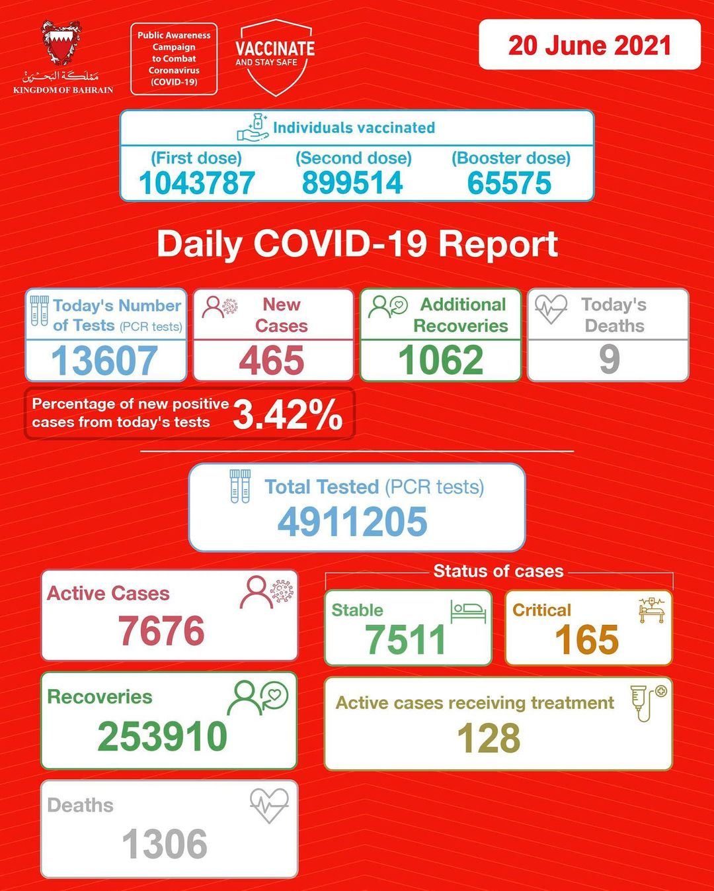
These are the stats for Bahrain. In short, the whole country is vaccinated (because there are severe penalties for non-compliance) but the COVID cases and deaths are actually higher now than before they ever started vaccinating people. Ouch!
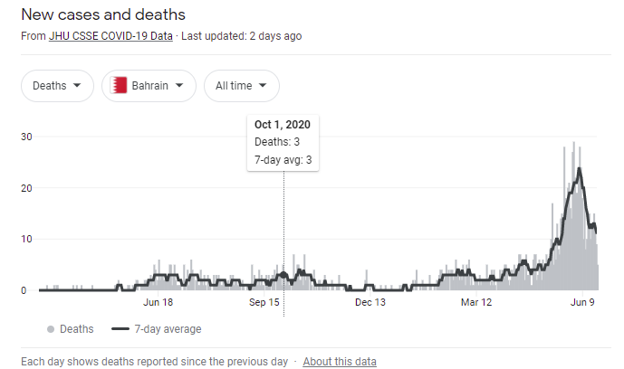
Bahrain was much better off before they required everyone in the country to be vaccinated. Whoops!

--------------------------
The medical community says it is perfectly safe for pregnant women to be vaccinated. Sure. They all just happened to lose their babies within weeks of the vaccine. We have a family friend--- same story. Unknown causes.

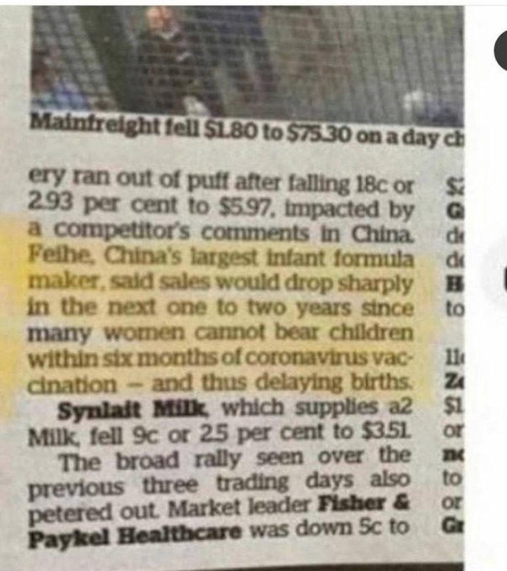
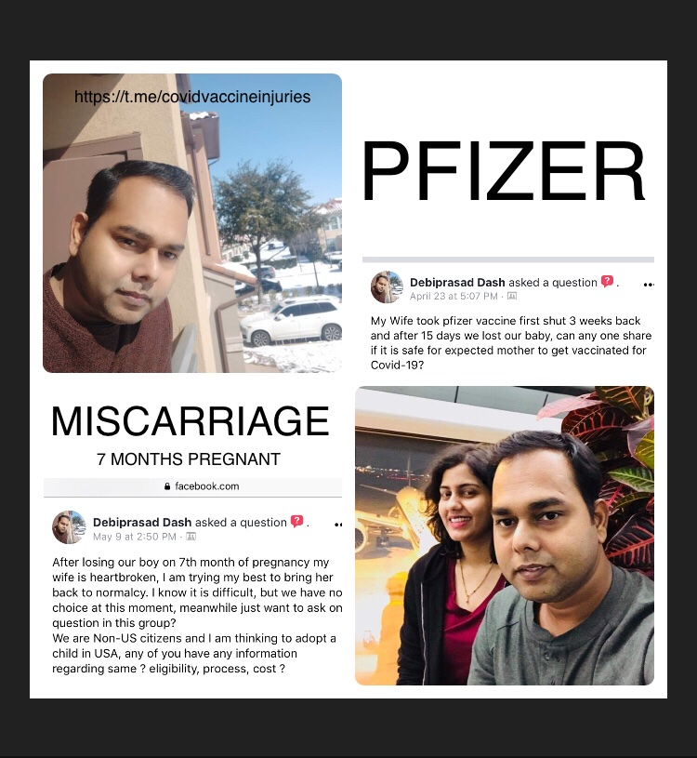

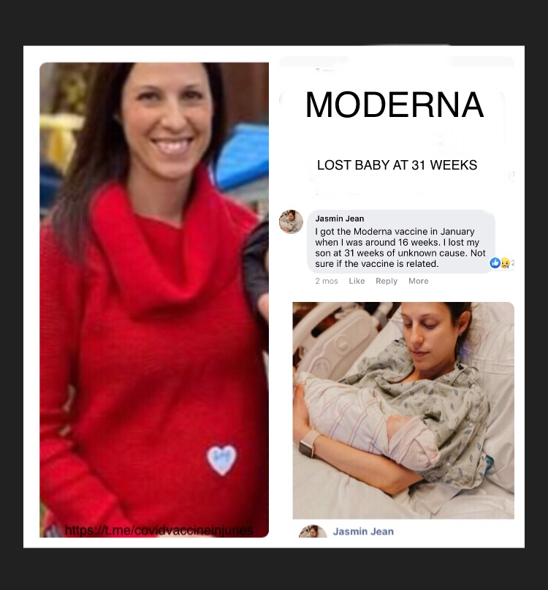

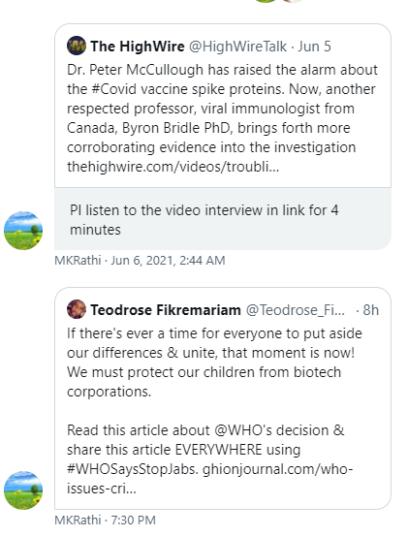

I watched the entire DarkHorse podcast video of you with Brian Weinstein and Dr Robert Malone. It was re-uploaded 2x by a new account on YouTube. Not sure how long it will remain on the platform. I learned about it on a podcast of Charlie Kirk’s. I dropped everything to watch it in its entirety. I shared both the Apple podcast and the link to the YouTube video already with friends. Thank you for continuing your efforts to get valuable, transparent information to the public, for trying to inform and influence government officials, and the hundreds of other touch points you are making in this on-going trauma and crimes against humanity due to COVID19. Since the start, I have been a proponent of the use of prophylactics, vital need for early treatment with existing therapeutics, and a strong opponent of ema “vaccines” on anyone (especially women and children). We cannot give up nor give in on any battlefront. This is a war against humanity. It takes everything within us to continue forward, even when they call us crazy (which is the least of their insults). Day by day more and more people in all walks of life and spheres of influence are joining with us. Thanks Steve, you are making a difference. Ellen in Arizona
------------------------------------

I cannot thank you enough for raising my awareness. Only time will tell how this all plays out.

I'm now noticing how just raising valid questions within my circle of friends and family is triggering cognitive dissonance.

Three concerning incidents I would like to highlight to you.

(1). My friend who is a 40-year-old male, with no underlying medical conditions, developed severe heart palpitations within six weeks of receiving his first dose of the AstraZeneca vaccine. The pain was severe enough that he went to hospital in the middle of the night. According to the Cardiologist, the cause could not be established, though it might be stress related. The vaccination did not come up in the conversation with the Doctor.

(2). My brother-in-law who is also in his early 40s, with no underlying medical conditions, received a vaccination (unsure which type). Within the space of a few weeks, he blacked-out at work and was rushed to hospital. He then developed hives all over his body. The vaccination did not come up in the conversation with the Doctor.

(3). Yesterday I learnt my mother was diagnosed with diabetes. She is in her 70s and she is the first person to be diagnosed with diabetes in my family. She was fully vaccinated eight weeks ago. Apparently: “she was always borderline pre-diabetic”. The vaccination did not come up in the conversation with the Doctor.

It seems the standard practice after receiving a vaccination is that you are asked to wait for 15 mins before leaving the clinic.

This may explain why people are failing to make the most obvious connection between receiving the vaccine and their new medical conditions.

It is likely we are being primed to believe that adverse reactions can only occur within this arbitrary period. And anything that occurs after 15 minutes, cannot be attributed to the vaccines. It's almost like a socially and medically engineered blindspot.

---------------------------------
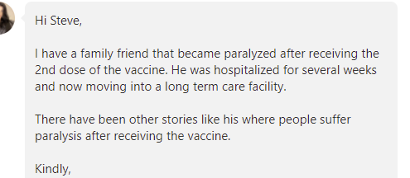
--------------------------
Trial Site News article (via LinkedIn)
I read your article on Trial Site News. I am a dentist, assistant professor, and sit on a national council of the ADA focused on advocacy and prevention. When Covid first hit and data was scarce, I followed the recommended mask and social distancing recommendations as most did. Over time, I became more alarmed by the group think and politicization of Covid. When talks of the vaccine began and the death rate was relatively low, I wondered why it was being so forcefully pushed in the media and on social platforms. Censorship put my suspicion over the edge. Anytime measures are taken to silence thoughtful discussion and scientific discourse, my alarm bells go off. Then, my own anecdotal experience validated all of what my instinct and intuition was telling me.

I had what I am sure to be a close, prolonged exposure to Covid. I was never symptomatic. I had two negative tests and a negative antibody test. I also work in what was designated as one of the highest risk professions for exposure. Yet, I was fine. Then the vaccine rolled out, and most of my clinical and academic colleagues and students lined up immediately to receive it, under strong encouragement from our administration and healthcare leaders. I considered it, realizing my colleagues might think I was a quack for not getting it. After all, I am the faculty member who teaches the public health curriculum for crying out loud! I am not a conspiracy theorist. But when I asked myself why I would be getting the vaccine if I chose to do so, I knew the answer was peer pressure, and I couldn't come to terms with that. I had been exposed. And I knew that either my own immune system had been capable or my chances of recovering if I did get it were excellent. So I opted not to get vaccinated. Now, by mandate, I have to submit to a weekly test to continue my teaching responsibilities at the dental school. Which is fine. 5 negative tests so far.

At my upcoming ADA Council meeting in July, I suspect in the public health company I'll be in, I will be likely the only unvaccinated in attendance. I have watched as the ADA has lobbied in favor of telling patients to get the vaccine and even lobby for dentists to be able to administer it. I will be required to wear a mask during the meeting (no science there), yet my vaccination status is supposedly "confidential."

I kept telling those close to me, "Since when do all the scientists not care abouts science?" "Why do we not care about testing and results?" "Why are low risk individuals being told to vaccinate when no data is available on the long term effects?" "Why are these alternative views being removed from or flagged in the media?" It all seemed weird and "off" to me. These seemed like reasonable, objective questions, yet I heard none of them from the mainstream narrative. As a friend of mine says, "The answer is money. What's the question?"

When I approached the PhD microbiology faculty member who gave a presentation on the vaccine to our faculty assembly to ask why those who had already been exposed or contracted Covid were being encouraged to vaccinate, the answer I got was, "Well, they THINK the immunity you get from the vaccine will last longer than the natural immunity exposure will provide." For me, that wasn't good enough. I need something better than that to inject something into my body for which, I know, I had little risk for adverse outcome in the first place. And now, your article shines the spotlight on why "They THINK..." isn't good enough.

Thank you for speaking out and trying to do right by the public. For standing up for intellectual honesty and the scientific method. I fear we will be reaping the consequences of this for years to come. I hope I'm wrong.

- Name withheld for fear of retribution (which is really sad to have to say that)
-----------------------------------------------
